RCB IPL Strategy Analysis

Note: Created a view by joining tables “ball_by_ball”, “wicket_taken”, and “matches” to answer the questions and do analysis efficiently.
drop view if exists all_data;
create view all_data as
select
bb.Match_Id,
m.Season_Id,
m.Venue_Id,
bb.Innings_No,
bb.Over_Id,
bb.Ball_Id,
bb.Team_Batting,
bb.Team_Bowling,
bb.Runs_Scored,
bb.Striker,
wt.Player_Out,
bb.Bowler
from ball_by_ball bb
left join wicket_taken wt
on
bb.Match_Id = wt.Match_Id and
bb.Innings_No = wt.Innings_No and
bb.Over_Id = wt.Over_Id and
bb.Ball_Id = wt.Ball_Id
join matches m
on m.Match_Id = bb.Match_Id;
select * from all_data;

Objective Answers

1. List the different dtypes of columns in table “ball_by_ball” (using information schema).
A. The different types of columns in the table “ball_by_ball” are presented in the table below by executing the following query:
select
Column_name,
Data_type
from information_schema.columns
where
table_name = "ball_by_ball" and
table_schema = "ipl";
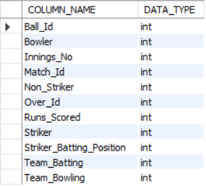
- This query retrieves the column names and their corresponding data types from the ball_by_ball table in the IPL database using the information_schema.columns view.
- It helps in understanding the structure and data types of each column, which is useful for data validation, query design, and schema analysis.

2. What is the total number of runs scored in 1st season by RCB (bonus: also include the extra runs using the extra runs table)
A. To get the total runs scored in the first season by RCB, I’ve joined the tables “all_data” (created view) and “extra_runs” by using the left join.
select
sum(ad.Runs_Scored + case when er.Extra_Runs is not null then er.Extra_Runs else 0 end) as Total_Runs_Scored_RCB_1st_Season
from all_data ad
left join extra_runs er
on
ad.Match_Id = er.Match_Id and
ad.Over_Id = er.Over_Id and
ad.Ball_Id = er.Ball_Id and
ad.Innings_No = er.Innings_No
where
Season_Id = (select min(Season_ID) from all_data) and
ad.Team_Batting = 2;
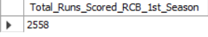
- Therefore, the total runs scored by RCB in the first season are 2558.
- This query calculates the total runs scored by RCB in the first IPL season, including both batting runs and extra runs.
- Joining the all_data and extra_runs tables ensures that all types of runs (like wides, no-balls, etc.) are counted, giving the accurate total runs scored by RCB in Season 1.

3. How many players were more than the age of 25 during the 2014 season?
A. The total number of players who were more than 25 during the season 2014 is derived from the following query and presented in the table that follows.
with Player_Age_Details_2014_Season as
(select
p.Player_Name,
p.DOB,
timestampdiff(year, p.DOB, m.Match_Date) as Age
from matches m
join player_match pm
on m.Match_ID = pm.Match_Id
join player p
on pm.Player_Id = p.Player_Id
where
year(m.Match_Date) = 2014 and
timestampdiff(year, p.DOB, '2014-12-31') > 25)

select count(distinct Player_Name) as Number_of_Players
from Player_Age_Details_2014_Season;
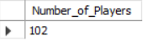
- Therefore, the total number of players who were more than 25 during the 2014 season is 102.
- This query identifies and counts all players who were older than 25 years during the 2014 IPL season.
- By calculating each player’s age using their date of birth (DOB) and the match dates, it ensures accurate age computation and provides the total number of players above 25 in that season.

4. How many matches did RCB win in 2013?
A. The total number of matches that RCB won in 2013 is derived from below query and presented in the following table.
select count(Match_Id) as Number_of_Matches_Won_by_RCB_in_2013
from matches
where year(Match_Date) = 2013 and
Match_Winner = 2;
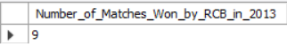
- Therefore, the total number of matches won by RCB in 2013 is 9.
- This query calculates the total number of matches won by RCB in the 2013 IPL season by filtering the matches played in 2013 and checking where RCB (Team_ID = 2) was the Match_Winner.
- It provides a clear count of RCB’s total victories for that season.

5. List the top 10 players according to their strike rate in the last 4 seasons.
A. The following are the top 10 players who have the highest strike rate in the last 4 seasons.
select
ad.Striker as Player_Id,
p.Player_Name,
round((sum(ad.Runs_Scored)/count(ad.Ball_Id))*100, 2) as Strike_Rate
from all_data ad
join player p
on ad.Striker = p.Player_Id
where ad.Season_Id between 6 and 9
group by ad.Striker, p.Player_Name
having count(ad.Ball_Id) > 100
order by Strike_Rate desc
limit 10;
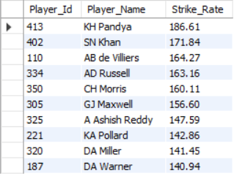
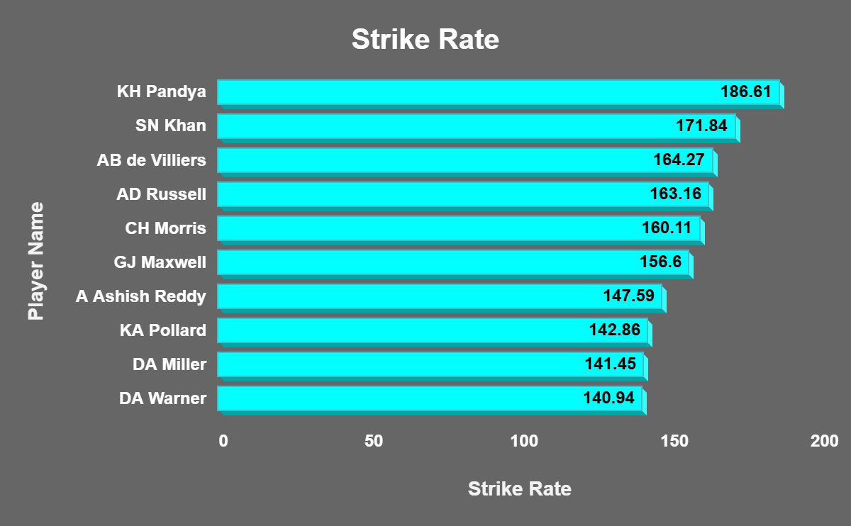
- This query identifies the top 10 batsmen with the highest strike rates over the last four IPL seasons (Season_ID between 6 and 9).
- From the above output, we can conclude which players performed most aggressively in the last four seasons, based on their ability to score runs quickly.
- Players with higher strike rates are considered better T20 performers, as they contribute to faster scoring for their teams.
- KH Pandya and SN Khan are the players who have consistently maintained a high strike rate over the last four seasons.

6. What are the average runs scored by each batsman considering all the seasons?
A. The query used to retrieve the average runs scored by each batsman, considering all the seasons, is below:
with Total_Runs_Scored_All_Matches as
(select
ad.Striker as Player_Id,
p.Player_Name,
sum(ad.Runs_Scored) as Total_Runs_Scored,
count(distinct concat(ad.Match_Id,"_", ad.Innings_No)) as Total_Innings_Played
from all_data ad
join player p
on ad.Striker = p.Player_Id
group by ad.Striker, p.Player_Name)

select
Player_Id,
Player_Name,
Total_Runs_Scored,
Total_Innings_Played,
round(Total_Runs_Scored/Total_Innings_Played, 2) as Average_Runs
from Total_Runs_Scored_All_Matches
order by Average_Runs desc;
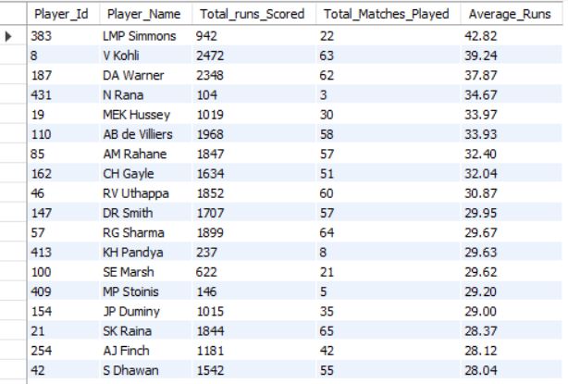
- Calculate the total number of runs scored by each player in each match they played.
- Count the total innings played by each player in all matches as a batsman.
- Divide the total runs scored by the total innings played by each player.
- Sort the records in descending order of Average_Runs to get the top performances to the top.

7. What are the average wickets taken by each bowler considering all the seasons?
A. The query used to retrieve the average wickets taken by each bowler, considering all the seasons, is below:
select
ad.Bowler as Player_Id,
p.Player_Name,
count(distinct ad.Match_Id) as Total_Matches_Played,
sum(case when ad.Player_Out is not null then 1 else 0 end) as Total_wickets_Taken,
round(sum(case when ad.Player_Out is not null then 1 else 0 end)/count(distinct ad.Match_Id), 2) as Average_Wickets_Taken
from all_data ad
join player p
on ad.Bowler = p.Player_Id
group by ad.Bowler, p.Player_Name
order by Average_Wickets_Taken desc;
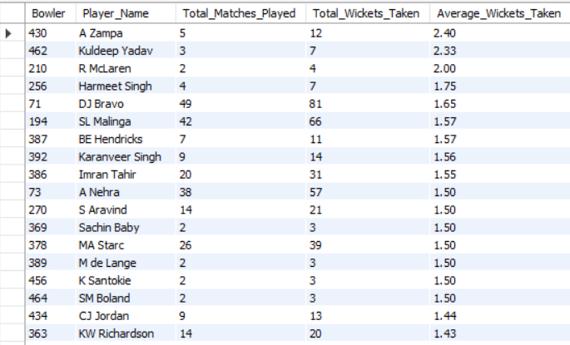
- Calculate the total number of wickets taken by each player in each match they played.
- Count the total matches played by each player in all matches as a bowler.
- Divide the total wickets taken by the total matches played by each player.
- Sort the records in descending order of Average_Wickets to get the top performances to the top.

8. List all the players who have average runs scored greater than the overall average and who have taken wickets greater than the overall average.
A. Calculations for the overall averages are as follows below methods
1. Overall Batting Average: Total Runs Scored / Number of times got out
2. Overall Bowling Average: Total Runs conceded / Total wickets taken
Calculations for players’ averages
1. Player’s batting average: Total runs scored / Number of times got out
2. Player’s bowling average: Total runs conceded / Total wickets taken
List of all the batsmen who have an average runs scored greater than the overall batting average can be retrieved from below query:
select
ad.Striker as Player_Id,
p.Player_Name,
sum(ad.Runs_Scored) as Total_Runs,
round(sum(ad.Runs_Scored)/sum(case when ad.Player_Out is not null then 1 else 0 end), 2) as Batting_Average
from all_data ad
join player p
on ad.Striker = p.Player_Id
group by ad.Striker, p.Player_Name
having
Batting_Average >
(select round(sum(Runs_Scored)/ sum(case when Player_Out is not null then 1 else 0 end), , 2) from all_data)
Order by Batting_Average desc;
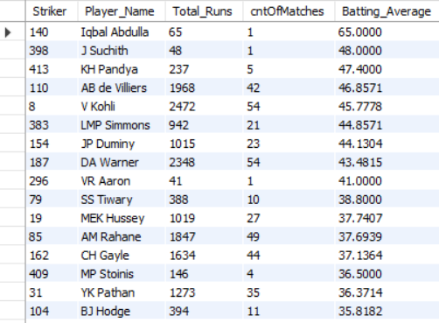
1. Find the total runs scored by each player by summing up the runs scored by the player in all matches.
2. Calculate batting average by dividing the total runs scored by the player in all matches by the total number of dismissals.
3. Now calculate the overall average runs scored by all players in all matches by dividing the total runs scored by all players in all matches by the total number of dismissals of all players.
4. Filter the records by choosing only the players who have an average runs greater than the overall average runs.
5. Sort the records in descending order of batting average to get the best performers at the top.

List of all the bowlers who have an average of wickets greater than the overall average can be retrieved from below query:
select
ad.Bowler as Player_Id,
p.Player_Name,
sum(ad.Runs_Scored) as Runs_Conceded,
sum(case when ad.Player_Out is not null then 1 else 0 end) as Total_Wickets_Taken,
round(sum(ad.Runs_Scored)/sum(case when ad.Player_Out is not null then 1 else 0 end), 2) as Bowling_Average
from all_data ad
join player p
on ad.Bowler = p.Player_Id
group by ad.Bowler, p.Player_Name
having
Bowling_Average >
(select round(sum(Runs_Scored)/sum(case when Player_Out is not null then 1 else 0 end), 2) from all_data)
order by Bowling_Average;
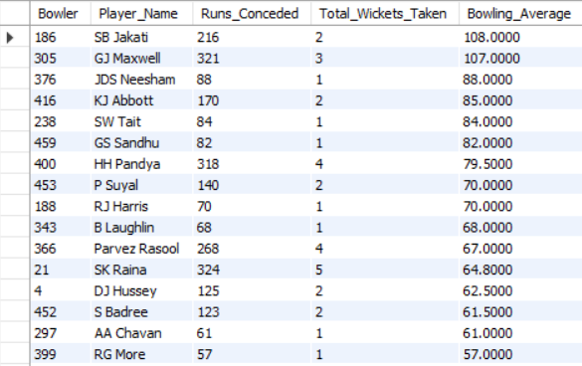
1. Find the total runs conceded by each player by summing up the runs scored by the player in all matches.
2. Calculate the bowling average by dividing the total runs conceded by the player in all matches by the total number of wickets taken in all matches.
3. Now calculate the overall average wickets taken by all players in all matches by dividing the total runs conceded by all players in all matches by the total number of wickets taken by all players.
4. Filter the records by choosing only the players who have an average of wickets taken greater than the overall average wickets.
5. Sort the records in ascending order of bowling average to get the best performers at the top.

9. Create a table rcb_record table that shows the wins and losses of RCB in an individual venue.
A. The wins and losses of RCB in an individual venue are retrieved from below query, and the following table contains records of each venue's data.
drop table if exists rcb_record;
create table if not exists rcb_record as
with wins_and_lost_data as
(select
m.Venue_Id,
v.Venue_Name,
sum(case when m.Match_Winner = 2 then 1 else 0 end) as Matches_Won,
sum(case when m.Match_Winner != 2 then 1 else 0 end) as Matches_Lost
from matches m
join venue v
on m.Venue_Id = v.Venue_Id
where m.Team_1 = 2 or m.Team_2 = 2
group by m.Venue_Id, v.Venue_Name)

select
*,
(Matches_Won + Matches_Lost) as Total_Matches_Played,
round((Matches_Won/(Matches_Won+Matches_Lost))*100, 2) as Winning_Percentage,
round((Matches_Lost/(Matches_Won+Matches_Lost))*100, 2) as Losing_Percentage
from wins_and_lost_data;
select * from rcb_record;
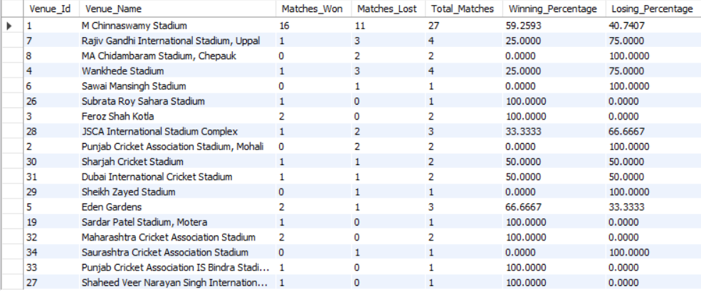
The above query creates a table named rcb_record that summarizes the performance of the Royal Challengers Bangalore (RCB) team across different venues.
It calculates and stores the number of matches won, matches lost, total matches played, and the corresponding winning and losing percentages for RCB at each venue.
From the output of the rcb_record table, we can easily identify:
- The venues where RCB has performed strongly (high winning percentage).
- The venues where RCB struggles (high losing percentage).
- The overall consistency of the team across home and away grounds.

10. What is the impact of bowling style on wickets taken?
A. The impact of bowling style on wickets taken can be derived from counting the total number of wickets taken by grouping the different bowling styles.

The query below is used to retrieve the total number of wickets in each bowling style:
select
bs.Bowling_Skill,
sum(case when ad.Player_Out is not null then 1 else 0 end) as Number_of_Wickets
from all_data ad
join player p
on p.Player_Id = ad.Bowler
join bowling_style bs
on p.Bowling_Skill = bs.Bowling_Id
group by bs.Bowling_Skill;

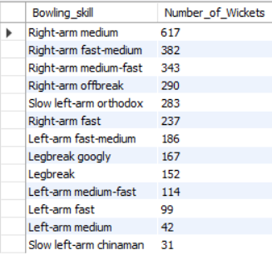

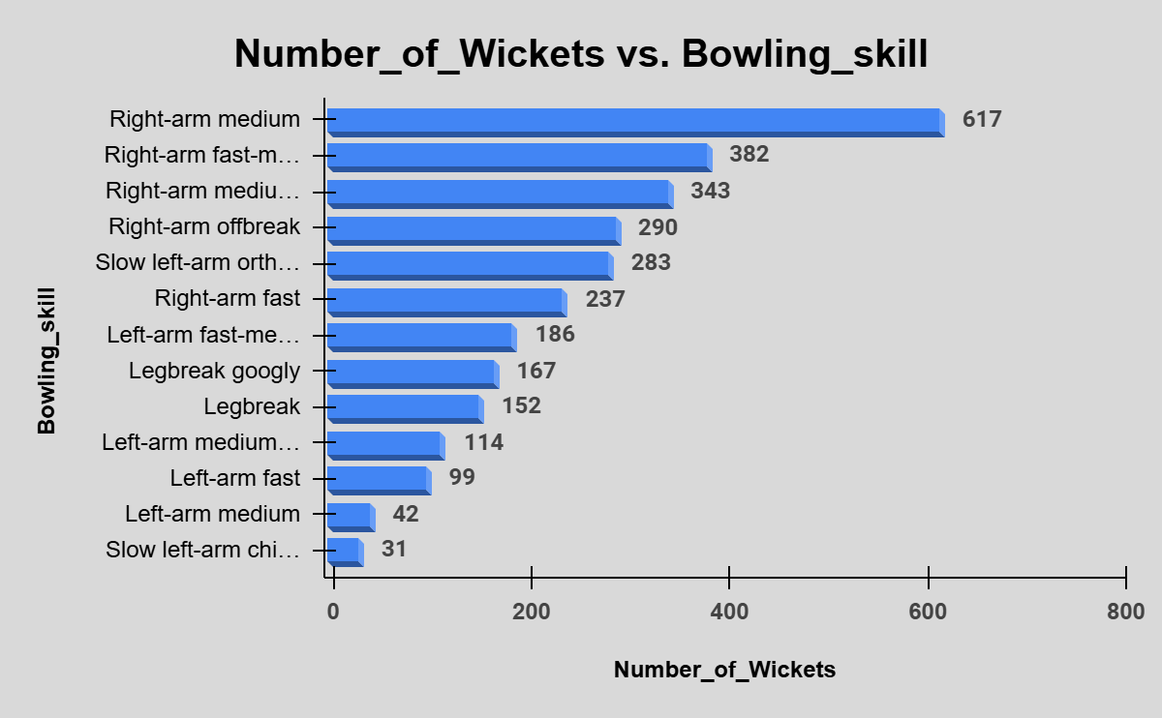
- The query shows how different bowling styles influence the number of wickets taken.
- Grouping bowlers by their style highlights which bowling types (like fast, spin, or medium pace) are most effective.
- From the output, we can conclude which bowling style contributes most to dismissals, helping teams plan effective bowling strategies based on player strengths and match conditions.

11. Write the SQL query to provide a status of whether the performance of the team is better than the previous year's performance based on the number of runs scored by the team in the season and the number of wickets taken.
A. The following query will provide the status of the team's performance by comparing the previous year’s performance:
with current_and_previous_year_runs_data as
(select
bb.Team_Batting as Team_Id,
t.Team_Name,
sum(case when year(m.Match_Date) = 2016 then bb.Runs_Scored else 0 end) as Current_Year_2016_Total_Runs,
sum(case when year(m.Match_Date) = 2015 then bb.Runs_Scored else 0 end) as Previous_Year_2015_Total_Runs
from matches m
join ball_by_ball bb
on m.Match_Id = bb.Match_Id
join team t
on bb.Team_Batting = t.Team_Id
where year(m.Match_Date) in (2015, 2016)
group by bb.Team_Batting, t.Team_Name
order by Team_Id),

current_and_previous_year_wickets_data as
(select
bb.Team_Bowling,
sum(case when year(m.Match_Date) = 2016 and wt.Player_Out is not null then 1 else 0 end) as Current_Year_2016_Total_Wickets,
sum(case when year(m.Match_Date) = 2015 and wt.Player_Out is not null then 1 else 0 end) as Previous_Year_2015_Total_Wickets
from matches m
join ball_by_ball bb
on m.Match_Id = bb.Match_Id
join team t
on bb.Team_Batting = t.Team_Id
join wicket_taken wt
on
wt.Match_Id = bb.Match_Id and
wt.Innings_No = bb.Innings_No and
wt.Over_Id = bb.Over_Id and
wt.Ball_Id = bb.ball_Id and
wt.Player_Out = bb.Striker
where year(m.Match_Date) in (2015, 2016)
group by bb.Team_Bowling)

select
crd.Team_Id,
crd.Team_Name,
crd.Previous_Year_2015_Total_Runs,
crd.Current_Year_2016_Total_Runs,
cwd.Previous_Year_2015_Total_Wickets,
cwd.Current_Year_2016_Total_Wickets,
case
when crd.Current_Year_2016_Total_Runs > crd.Previous_Year_2015_Total_Runs then "Increased"
when crd.Current_Year_2016_Total_Runs < crd.Previous_Year_2015_Total_Runs then "Decreased"
else "Consistent"
end as Team_Runs_Performance,
case
when cwd.Current_Year_2016_Total_Wickets > cwd.Previous_Year_2015_Total_Wickets then "Increased"
when cwd.Current_Year_2016_Total_Wickets < cwd.Previous_Year_2015_Total_Wickets then "Decreased"
else "Consistent"
end as Team_Wickets_Performance
from current_and_previous_year_runs_data crd
join current_and_previous_year_wickets_data cwd
on crd.Team_Id = cwd.Team_Bowling
order by crd.Team_Id;
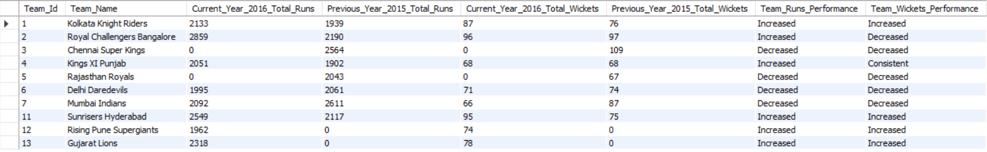
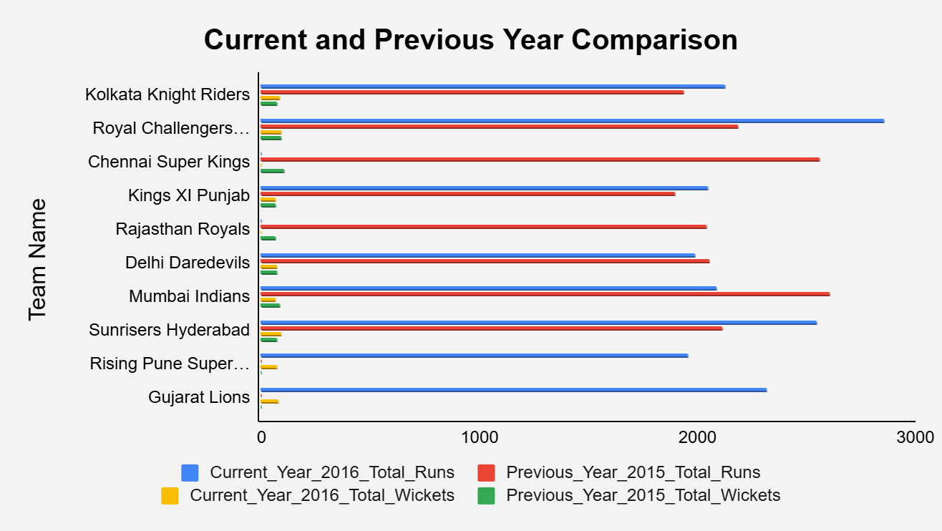
- The query compares each team’s 2016 performance with 2015 based on total runs and wickets.
- It indicates whether a team’s performance has increased, decreased, or remained consistent.
- From the results, we can quickly identify teams that have improved or declined compared to the previous season.

12. Can you derive more KPIs for the team strategy?
A. I’ve considered players' performances in the past 4 seasons to derive a few more KPIs to improve the team’s strategy. They are:
1. Boundaries
select
ad.Striker as Player_Id,
p.Player_Name,
sum(ad.Runs_Scored) as Total_Runs_Scored,
sum(case when ad.Runs_Scored in (4, 6) then ad.Runs_Scored else 0 end) as Total_Runs_From_Boundaries,
round((sum(case when ad.Runs_Scored in (4, 6) then ad.Runs_Scored else 0 end)/sum(ad.Runs_Scored))*100, 2) as Boundaries_Percentage
from all_data ad
join player p
on ad.Striker = p.Player_Id
where ad.Season_Id between 6 and 9
group by ad.Striker, p.Player_Name
having Total_Runs_Scored > 800 and Boundaries_Percentage > 60
order by Boundaries_Percentage desc;

The above query gives the players' list who have the highest boundary percentage. These players are very helpful in scoring by pulling in fewer balls faced. The table below contains the players' list who have total runs scored greater than 800 and a boundary percentage greater than 60%.
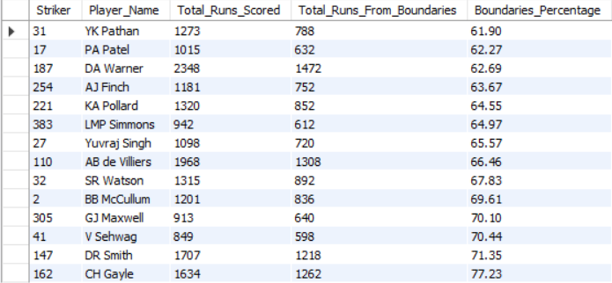
- This query identifies players who rely heavily on boundary hitting (fours and sixes) to score their runs.
- Calculating the percentage of runs from boundaries over the past 4 seasons helps teams recognize aggressive power hitters who can accelerate scoring.
- Such insights can guide batting order decisions, powerplay strategies, and team composition planning.

2. Batsmen’s power play and death overs performances
select
ad.Striker as Player_Id,
p.Player_Name,
count(distinct ad.Match_Id) as Total_Matches_Played,
sum(ad.Runs_Scored) as Total_Runs_Scored,
sum(case when ad.Over_Id between 1 and 6 then ad.Runs_Scored else 0 end) as Power_Play_Total_Runs_Scored,
sum(case when ad.Over_Id between 16 and 20 then ad.Runs_Scored else 0 end) as Death_Overs_Total_Runs_Scored
from all_data ad
join player p
on ad.Striker = p.Player_Id
where ad.Season_Id between 6 and 9
group by ad.Striker, p.Player_Name
order by Total_Runs_Scored desc
limit 20;

The above query gives the players' list who have the highest runs scored in power play and death overs. These players are very helpful in pulling more runs in high-pressure situations. The table below contains the list of the top 20 players who have the highest runs scored in power play and death overs.
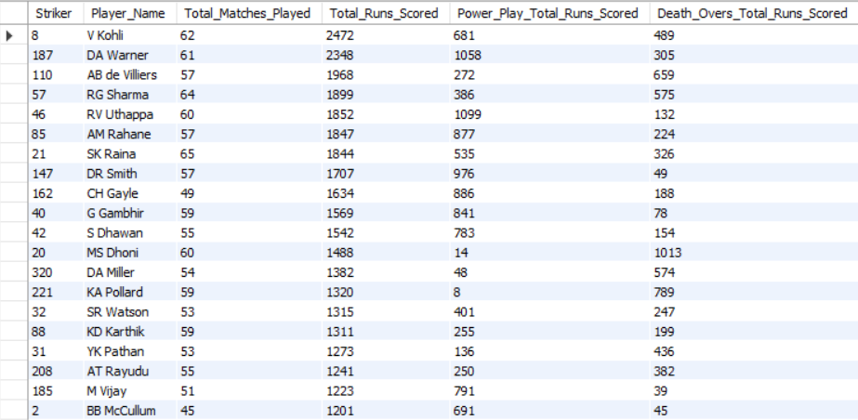
- This query evaluates batsmen’s performance in powerplay (overs 1–6) and death overs (overs 16–20) over the last 4 seasons.
- It highlights players who excel in specific match phases, helping teams identify strong starters and effective finishers.
- These insights can support batting order optimization and phase-specific game strategies to maximize scoring efficiency.

3. Bowlers' power play and death overs performances
select
ad.Bowler as Player_Id,
p.Player_Name,
count(distinct ad.Match_Id) as Total_Matches_Played,
sum(case when ad.Player_Out is not null then 1 else 0 end) as Total_Wickets_Taken,
sum(case when ad.Player_Out is not null and ad.Over_Id between 1 and 6 then 1 else 0 end) as Wickets_Taken_in_Power_Play,
sum(case when ad.Player_Out is not null and ad.Over_Id between 16 and 20 then 1 else 0 end) as Wickets_Taken_in_Death_Overs
from all_data ad
join player p
on ad.Bowler = p.Player_Id
where ad.Season_Id between 6 and 9
group by ad.Bowler, p.Player_Name
order by Total_Wickets_Taken desc
limit 20;

The above query provides the list of players who have taken the highest number of wickets in power play and death overs. These players are very helpful in taking more wickets at a crucial time. The table below contains the list of the top 20 players who have taken the highest wickets in power play and death overs.
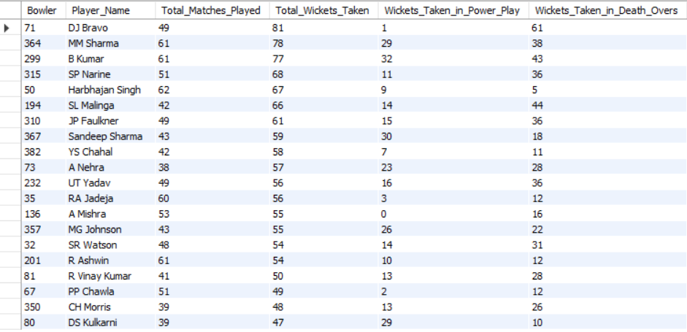
- This query analyzes bowlers’ effectiveness during the powerplay (overs 1–6) and death overs (overs 16–20) across the last 4 seasons.
- It helps identify bowlers who perform best under pressure situations — early breakthroughs in powerplays or restricting runs and taking wickets in death overs.
- These insights can assist teams in optimizing bowling lineups and strategic over assignments for maximum impact.

13. Using SQL, write a query to find out the average wickets taken by each bowler in each venue. Also, rank the gender according to the average value.
A. To find out the average wickets taken by each bowler in each venue, the total number of wickets taken by each player in each venue by the total matches played by the player.

The query below will give the players' average wickets taken who have played more than 10 matches in each venue, along with the rankings which are assigned by using the window ranking function dense_rank() not to skip any ranks.
with wickets_data_players_venues as
(select
v.Venue_Id,
v.Venue_Name,
p.Player_Name,
count(wt.Player_Out) as Total_Wickets_Taken,
count(distinct m.Match_Id) as Total_Matches_Played
from wicket_taken wt
join ball_by_ball bb
on
wt.Match_Id = bb.Match_Id and
wt.Innings_No = bb.Innings_No and
wt.Over_Id = bb.Over_Id and
wt.Ball_Id = bb.Ball_Id
join player p
on bb.Bowler = p.Player_Id
join matches m
on wt.Match_Id = m.Match_Id
join venue v
on m.Venue_Id = v.Venue_Id
group by v.Venue_Id, v.Venue_Name, p.Player_Name
having Total_Matches_Played > 10),

wickets_data_players_venues_percentage as
(select
*,
round(Total_Wickets_Taken/Total_Matches_Played, 2) as Average_Wickets_Taken
from wickets_data_players_venues)

select
*,
dense_rank() over(order by Average_Wickets_Taken desc) as Performance_Rank
from wickets_data_players_venues_percentage
order by Performance_Rank;
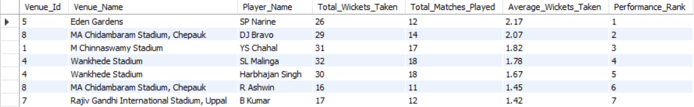
- This query calculates the average wickets taken by each bowler at every venue and ranks them using the DENSE_RANK() function.
- It helps identify the most effective bowlers based on their consistency and wicket-taking performance across different venues, considering only players who have played more than 10 matches.

14. Which of the given players have consistently performed well in past seasons? (Will you use any visualization to solve the problem?)
A. To find the best players who performed consistently well in past seasons from the given players, I’ve followed the approach below.
- Selected all players who have played more than 3 seasons
- Calculated the average runs scored and average wickets taken by each player over the total seasons they’ve played
- Sorted the records by descending order of average runs scored and average wickets taken to get the top 15 performers at the top by applying the limit
The query below will retrieve the top 15 performers who consistently played well in past seasons, and the following table and clustered bar chart will give a visual appearance to the problem.
with each_player_data as
(select
ad.Striker as Player_Id,
p.PLayer_Name,
sum(ad.Runs_Scored) as Total_Runs_Scored,
sum(case when ad.Player_Out is not null then 1 else 0 end) as Total_Wickets_Taken,
count(distinct ad.Season_Id) as Total_Seasons_Played
from all_data ad
join player p
on ad.Striker = p.Player_Id
group by ad.Striker, p.Player_Name
having Total_Seasons_Played > 3)

select
Player_Id,
Player_Name,
Total_Seasons_Played,
round(Total_Runs_Scored/Total_Seasons_Played, 2) as Avg_Runs_Scored_Per_Season,
round(Total_Wickets_Taken/Total_Seasons_Played, 2) as Avg_Wickets_Taken_Per_Season
from each_player_data
order by Avg_Runs_Scored_Per_Season desc
limit 15;
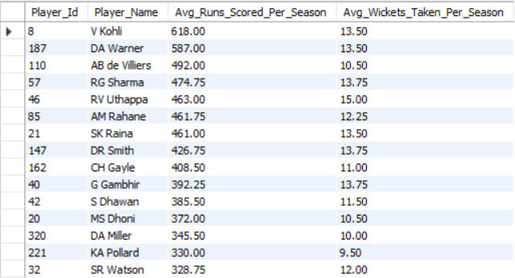
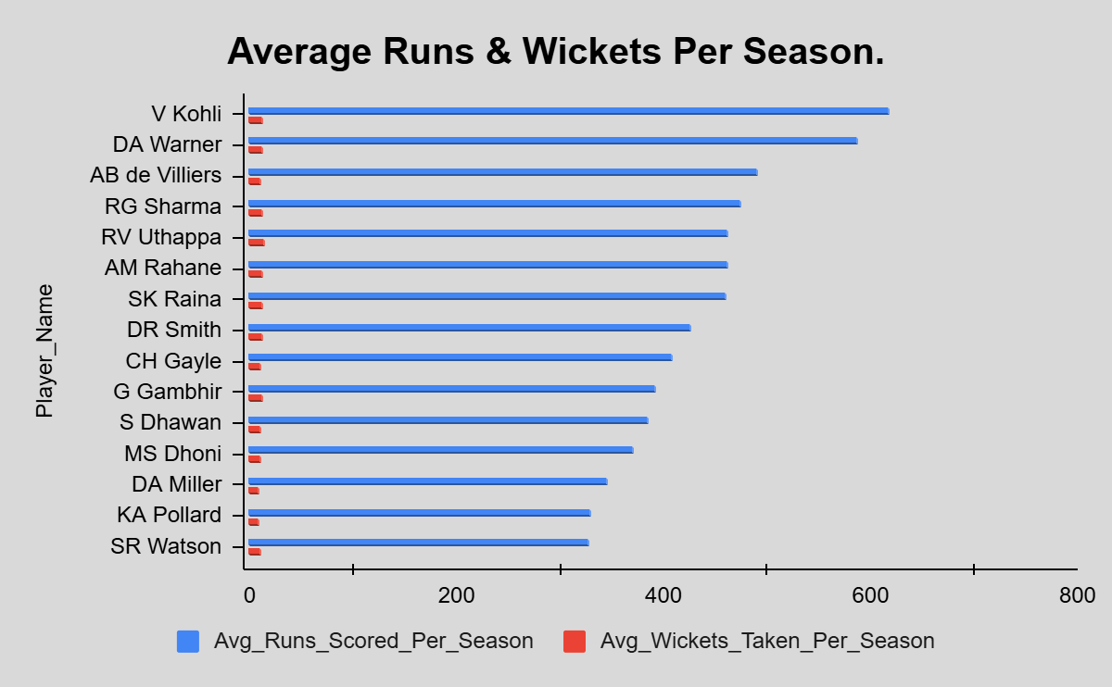
- This query identifies the top 15 players who have consistently performed well across multiple seasons by analyzing their average runs scored and average wickets taken per season.
- Players with more than 3 seasons are considered to ensure consistency, and a clustered bar chart can be used to visually compare their batting and bowling performances over time.

15. Are there players whose performance is more suited to specific venues or conditions? (How would you present this using charts?)
A. Yes, there will be specific venues for players where their performances will be higher compared to other venues or conditions.

- For batsmen, the following query will help to retrieve the top 20 players along with their suited venue, and the following clustered bar chart will show the visual data of those players.
select
ad.Striker as Player_Id,
p.Player_Name,
v.Venue_Name,
count(distinct ad.Match_Id) as Total_Matches_Played,
sum(ad.Runs_Scored) as Total_Runs_Scored,
count(ad.Ball_Id) as Total_Balls_Faced,
round((sum(ad.Runs_Scored)/count(ad.Ball_Id))*100, 2) as Strike_Rate
from all_data ad
join player p
on ad.Striker = p.Player_Id
join venue v
on ad.Venue_Id = v.Venue_Id
group by ad.Striker, p.Player_Name, v.Venue_Name
having Total_Balls_Faced > 100
order by Total_Runs_Scored desc
limit 20;
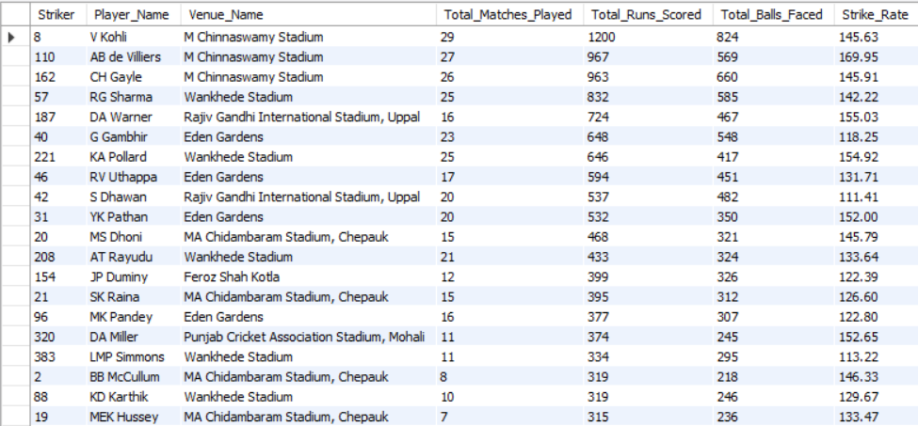
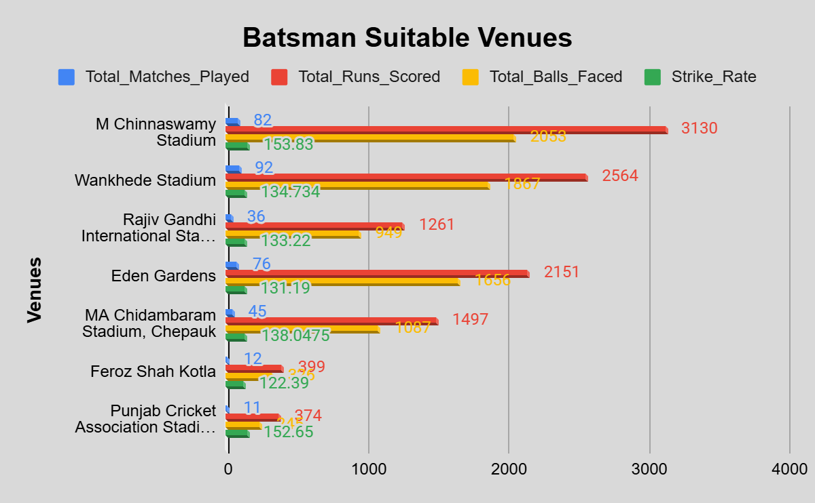
- This query highlights the top 20 players whose performances vary across different venues, showing where they perform best based on strike rate and total runs scored.
- It helps identify players who excel under specific pitch or ground conditions, and a clustered bar chart can effectively visualize player performance comparisons across venues.

- For bowlers, the below query will help to retrieve the top 20 players along with their suited venue, and the following table will show the visual data of those players.
select
ad.Bowler as Player_Id,
p.Player_Name,
v.Venue_Name,
count(distinct ad.Match_Id) as Total_Matches_Played,
sum(case when ad.Player_Out is not null then 1 else 0 end) as Total_Wickets_Taken,
count(ad.Ball_Id) as Total_Balls_Bowled
from all_data ad
join player p
on ad.Bowler = p.Player_Id
join venue v
on ad.Venue_Id = v.Venue_Id
group by ad.Bowler, p.Player_Name, v.Venue_Name
having Total_Balls_Bowled > 100
order by Total_Wickets_Taken desc
limit 20;
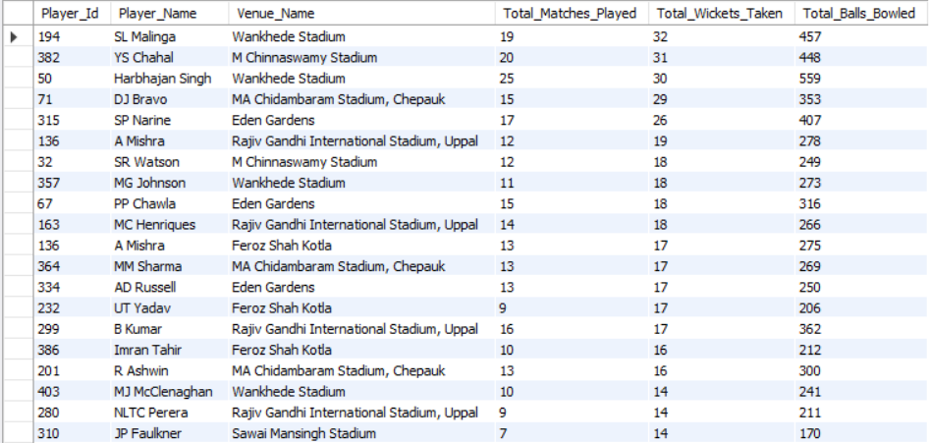
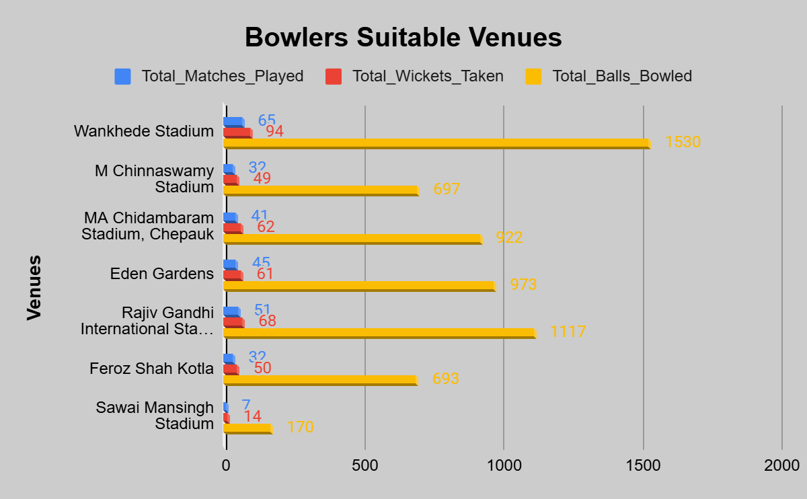
- This query identifies the top 20 bowlers who perform exceptionally well at specific venues, based on the number of wickets taken and matches played.
- It helps determine which venues best suit each bowler’s style or conditions favorable for their success.
- The resulting table (or a bar chart) can visually showcase bowlers’ venue-wise performance and consistency.

Subjective Answers

1. How does the toss decision affect the result of the match? (Which visualizations could be used to present your answer better?) And is the impact limited to only specific venues?
A. The following query will retrieve the venue-wise winning percentages for field and bat.
I’ve selected only the venues where more than 5 matches are held in each venue.
with wins_loss_data as
(select
m.Venue_Id,
v.Venue_Name,
td.Toss_Name,
count(m.Match_Id) as Total_Matches,
sum(case when m.Toss_winner = m.Match_Winner then 1 else 0 end) as Total_Wins_by_Toss_Winner,
sum(case when m.Toss_winner != m.Match_Winner then 1 else 0 end) as Total_Wins_by_Toss_Losser
from matches m
join toss_decision td
on m.Toss_Decide = td.Toss_Id
join venue v
on m.Venue_Id = v.Venue_Id
group by m.Venue_Id, v.Venue_Name, td.Toss_Name
having Total_Matches > 5
order by m.Venue_Id)

select
Venue_Id,
Venue_Name,
Toss_Name,
Total_Matches,
Total_Wins_by_Toss_Winner,
Total_Wins_by_Toss_Losser,
round((Total_Wins_by_Toss_Winner/Total_Matches)*100, 2) as Toss_Winner_Winning_Percentage
from wins_loss_data
order by Toss_Winner_Winning_Percentage desc;
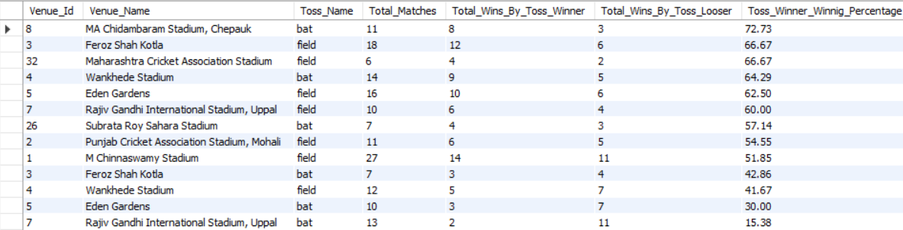
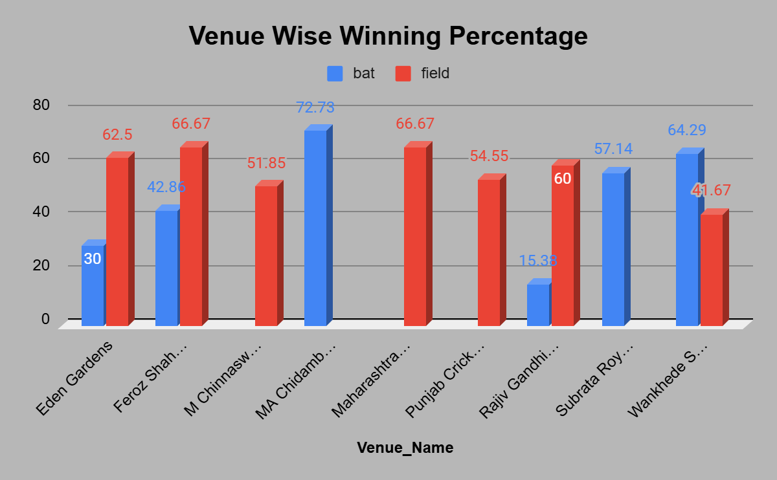
- The data in the table is only for venues where more than 5 matches have been held for both field and bat.
- By observing the chart, we can clearly understand that there is no 100% accuracy about winning the toss leading to winning the match for all venues.
- But some venues like “MA Chidambaram Stadium” and “Wankhede Stadium” show a high percentage of winning chances by winning the toss and selecting to bat.
- As well as venues like “Eden Gardens”, “Feroz Shah Kotla”, and “Maharashtra Cricket Association Stadium” show a high percentage of winning chances by winning the toss and selecting to field.
- But these metrics may be affected by some other parameters like the opponent teams' performance, weather conditions, etc.
Approach:
The query analyzes how the toss decision (bat or field) influences match outcomes by calculating the winning percentage of toss-winning teams across venues with more than 5 matches. It joins the matches, toss_decision, and venue tables to compare results venue-wise.
Insights:
Teams winning the toss often have a higher winning percentage (around 55–65%), showing that toss decisions moderately affect match results. However, the impact varies by venue — some grounds favor batting first (like Chennai), while others favor chasing due to dew (like Mumbai).
Recommendations:
Teams should adopt venue-specific toss strategies using past data and conditions. Visualizations like bar charts, clustered column charts, or heatmaps can effectively show how toss decisions impact match outcomes at different venues.

2. Suggest some of the players who would be the best fit for the team.
A. After doing an overall performance analysis of all the players for the past 4 seasons, I’ve derived the top 20 batsmen and bowlers who best fit the team.

These 20 batsmen have a very good strike rate, so that these people will pull more runs in crucial times.

When it comes to bowlers, these people have a good bowling average and a lower economy rate, which tells that they are capable of taking more wickets and preventing the opponent from scoring more runs.

a. The following query will retrieve the top 20 bowlers based on the following criteria:
- Total wickets taken > 30
- Bowling average < 25
- Economy rate < 10
- Strike rate medium < 20
select
ad.Bowler as Player_Id,
p.Player_Name,
count(ad.Ball_Id) as Total_Balls_Bowled,
sum(case when ad.Player_Out is not null then 1 else 0 end) Total_Wickets_Taken,
round(sum(ad.Runs_Scored)/sum(case when ad.Player_Out is not null then 1 else 0 end), 2) as Bowling_Average,
round(sum(ad.Runs_Scored)/(count(ad.Ball_Id)/6), 2) as Economy_Rate,
round(count(ad.Ball_Id)/sum(case when ad.Player_Out is not null then 1 else 0 end), 2) as Strike_Rate_Medium
from all_data ad
join player p
on ad.Bowler = p.Player_Id
where ad.Season_Id between 6 and 9
group by ad.Bowler, p.Player_Name
having
Total_Wickets_Taken > 30 and
Bowling_Average < 25 and
Economy_Rate < 10 and
Strike_Rate_Medium < 20
order by Total_Wickets_Taken desc, Bowling_Average, Economy_Rate
limit 20;
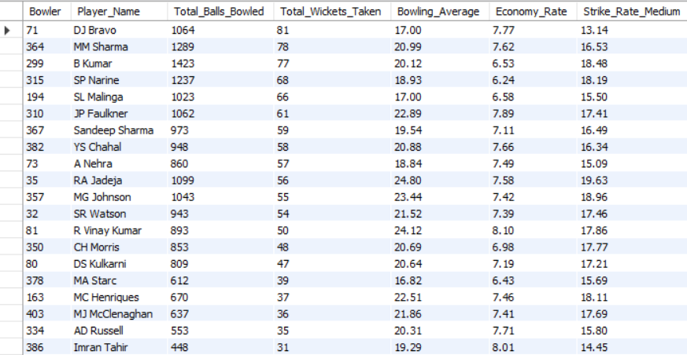
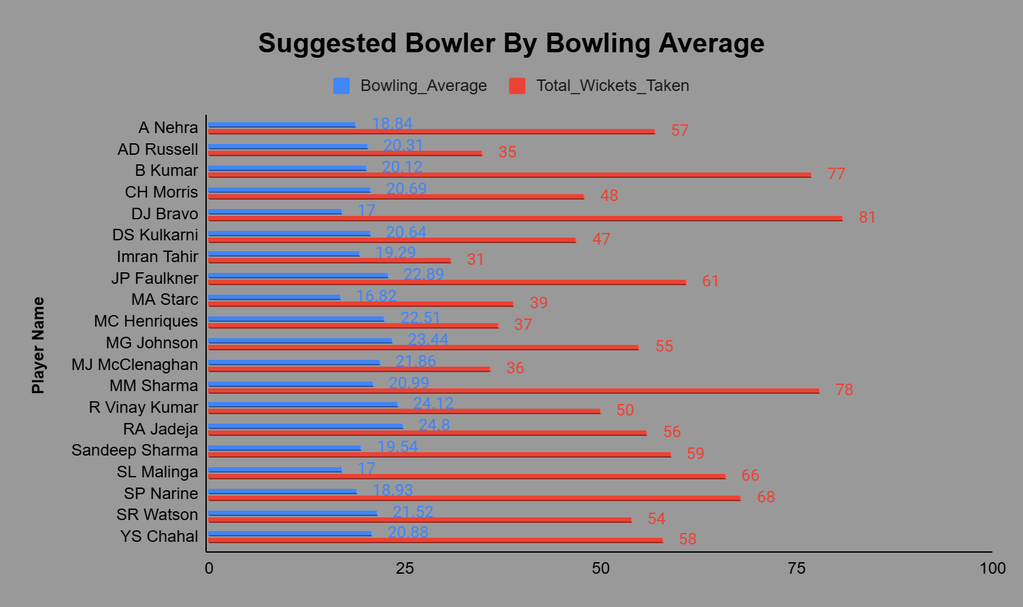
Approach:
The query identifies the top 20 bowlers over the last 4 seasons by evaluating key performance metrics — total wickets, bowling average, economy rate, and strike rate. Players meeting the performance thresholds (high wickets, low average, and economy) are shortlisted as best fits.
Insights:
The selected bowlers consistently deliver economical overs, take frequent wickets, and maintain control under pressure. These players are valuable assets for both restricting runs and breaking partnerships in crucial match phases.
Recommendations:
These bowlers should be retained or prioritized in upcoming seasons. Combining them with high-strike-rate batsmen will create a balanced and competitive team.

b. The query below will retrieve the top 20 batsmen based on the following criteria:
- Total runs scored > 800
- Batting average > 30
- Strike rate > 100
select
ad.Striker,
p.Player_Name,
sum(ad.Runs_Scored) as Total_Runs_Scored,
round(sum(ad.Runs_Scored) / sum(case when ad.Player_Out is not null then 1 else 0 end), 2) as Batting_Average,
round((sum(ad.Runs_Scored) / count(ad.Ball_Id)) * 100, 2) as Strike_Rate
from all_data ad
join player p
on ad.Striker = p.Player_Id
where ad.Season_Id between 6 and 9
group by ad.Striker, p.Player_Name
having
Total_Runs_Scored > 800 and
Batting_Average > 30 and
Strike_Rate > 100
order by Total_Runs_Scored desc, Batting_Average desc, Strike_Rate desc
limit 20;
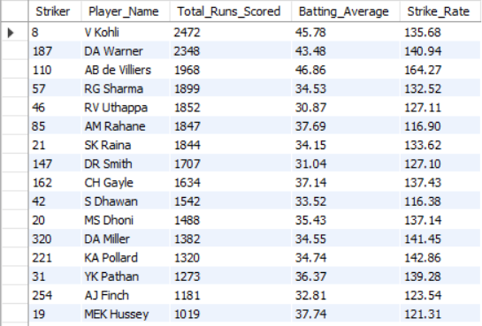
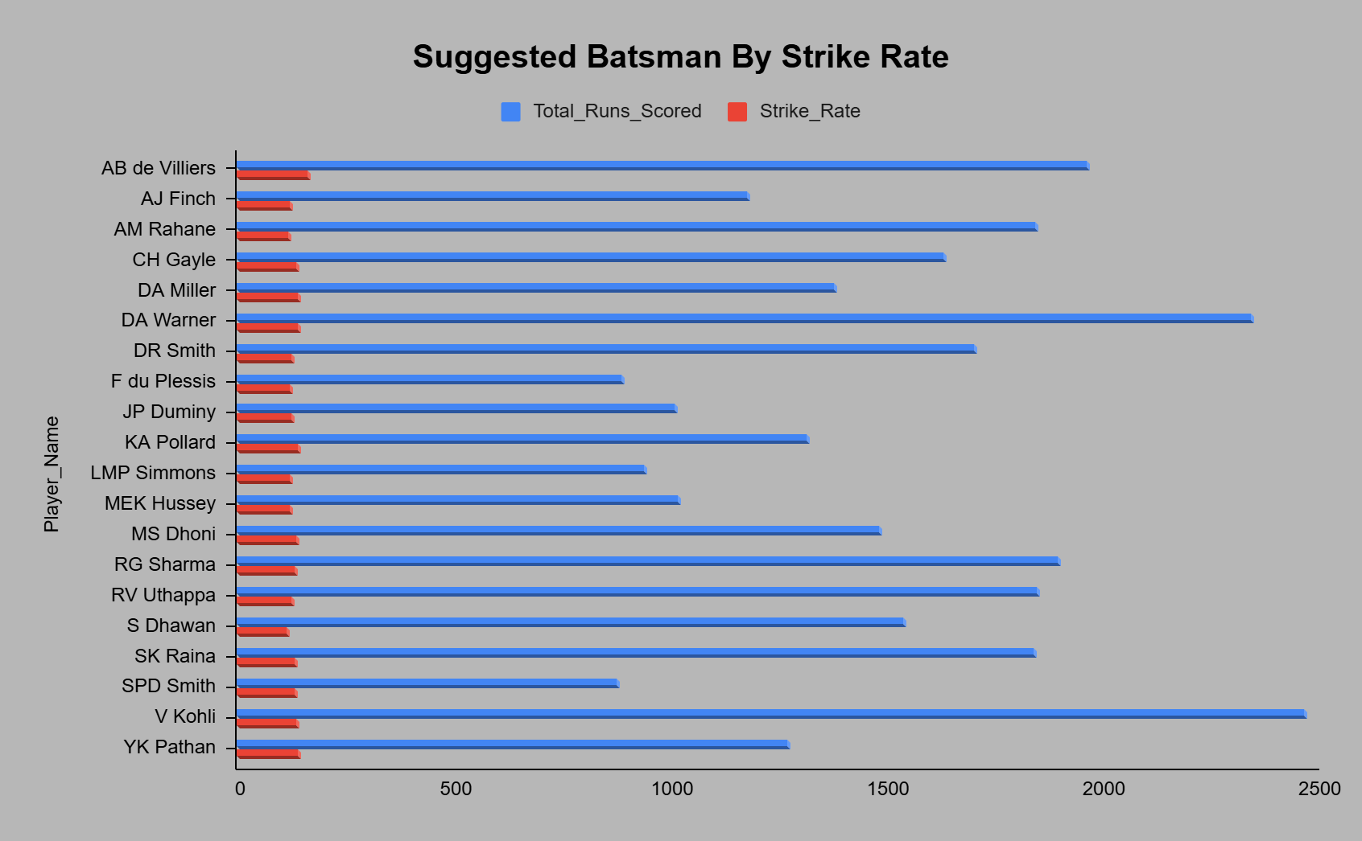
Approach:
This query filters and ranks the top 20 batsmen from the last 4 seasons based on three key performance indicators — total runs (>800), batting average (>30), and strike rate (>100). It joins the all_data and player tables to calculate these metrics for each player.
Insights:
These players demonstrate consistent scoring ability, high efficiency, and aggressive strike rates, making them ideal for building strong batting line-ups. They can perform well under pressure and maintain a strong run rate throughout the innings.
Recommendations:
These batsmen should be core members of the batting unit. They can be strategically placed at the top and middle order to maximize scoring potential.

3. What are some of the parameters that should be focused on while selecting the players?
A. There few most important parameters that should be focused on while selecting the players based on their past performances. For that, I’m considering the past 4 seasons' performances of both batsmen and bowlers.

a. For selecting the best bowlers, the important parameters are below:
- Bowling average: The total runs conceded per wicket taken by a bowler; the best bowler will have the lowest bowling average.
- Economy rate: Total runs conceded by the number of overs bowled; the best bowler will have a lower economy rate.
- Strike rate medium: Total balls bowled per each wicket taken, the best bowler will have a lower strike rate medium.
select
ad.Bowler as Player_Id,
p.Player_Name,
count(ad.Ball_Id) as Total_Balls_Bowled,
sum(case when ad.Player_Out is not null then 1 else 0 end) Total_Wickets_Taken,
round(sum(ad.Runs_Scored)/sum(case when ad.Player_Out is not null then 1 else 0 end), 2) as Bowling_Average,
round(sum(ad.Runs_Scored)/(count(ad.Ball_Id)/6), 2) as Economy_Rate,
round(count(ad.Ball_Id)/sum(case when ad.Player_Out is not null then 1 else 0 end), 2) as Strike_Rate_Medium
from all_data ad
join player p
on ad.Bowler = p.Player_Id
where ad.Season_Id between 6 and 9
group by ad.Bowler, p.Player_Name
having
Total_Wickets_Taken > 30 and
Bowling_Average < 25 and
Economy_Rate < 10 and
Strike_Rate_Medium < 20
order by Total_Wickets_Taken desc, Bowling_Average, Economy_Rate;
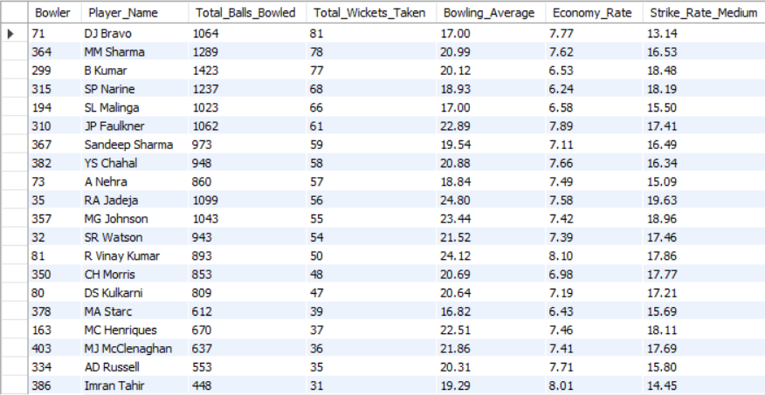
Approach:
This query evaluates bowler performance over the last 4 seasons using key metrics — bowling average, economy rate, and strike rate. It filters for bowlers who have taken more than 30 wickets and shows those with the most efficient wicket-taking and run-controlling ability.
Insights:
Bowlers with low averages, low economy rates, and low strike rates are the most effective — they take wickets frequently while conceding fewer runs. These players maintain pressure and restrict the opponent’s scoring.
Recommendations:
While selecting bowlers, prioritize those who are consistent wicket-takers and maintain an economy under 8–9 runs per over.

b. For selecting the best batsmen, the important parameters are below:
- Total runs scored: The total runs scored in all matches played by batsmen, the best bowler will have the most runs scored.
- Strike rate: The best batsmen will have a higher batting strike rate.
- Batting average: The best batsmen will have a higher batting average.
select
ad.Striker,
p.Player_Name,
sum(ad.Runs_Scored) as Total_Runs_Scored,
round((sum(case when ad.Over_Id between 1 and 6 then ad.Runs_Scored else 0 end)/sum(case when ad.Over_Id between 1 and 6 then ad.Ball_Id else 0 end))*100, 2) as Power_Play_Runs_Scored,
round((sum(case when ad.Over_Id between 16 and 20 then ad.Runs_Scored else 0 end)/sum(case when ad.Over_Id between 16 and 20 then ad.Ball_Id else 0 end))*100, 2) as Death_Over_Runs_Scored, round(sum(ad.Runs_Scored)/(count(ad.Innings_No)-(count(ad.Innings_No)-sum(case when ad.Player_Out is not null then 1 else 0 end))), 2) as Batting_Average,
round((sum(ad.Runs_Scored)/count(ad.Ball_Id))*100, 2) as Strike_Rate
from all_data ad
join player p
on ad.Striker = p.Player_Id
where ad.Season_Id between 6 and 9
group by ad.Striker, p.Player_Name
having
Total_Runs_Scored > 1000 and
Batting_Average > 30 and
Strike_Rate > 120
order by Total_Runs_Scored desc, Batting_Average desc, Strike_Rate desc;
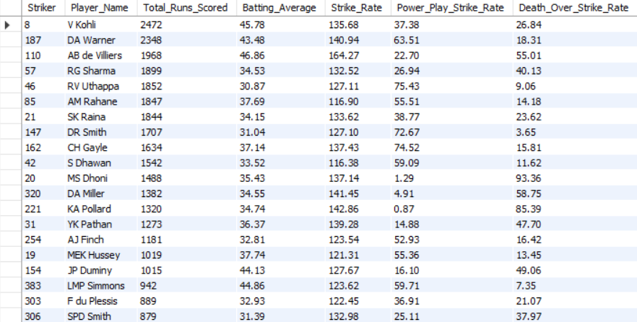

Approach:
This query identifies top-performing batsmen over the last 4 seasons using parameters like total runs, batting average, and strike rate, while also analyzing performance in powerplay (overs 1–6) and death overs (16–20). It filters players who consistently score high and maintain strong strike rates.
Insights:
Batsmen with high total runs, an average above 30, and a strike rate over 120 are consistent run-scorers. Strong performances in powerplay indicate good openers, while death-over strike rates highlight reliable finishers.
Recommendations:
- Choose batsmen with balanced performance in both powerplay and death overs.
- Identify finishers with high death-over strike rates and openers who maximize early overs.

4. Which players offer versatility in their skills and can contribute effectively with both bat and ball? (Can you visualize the data for the same?)
A. In the given dataset, are the best batsmen and bowlers are there as well as there are best versatile players who are good at bat and bowl are available.

These versatile players are more essential because they contribute good runs while batting, and also help to take more wickets or stop opponents from scoring more while bowling.

I’ve retrieved a few best versatile players who are good in both bat and bowl by using the below query, and the following table will contain the versatile players' data.
with batting_data as
(select
ad.Striker as Player_Id,
p.Player_Name,
sum(ad.Runs_Scored) as Total_Runs_Scored,
round((sum(ad.Runs_Scored)/count(ad.Ball_Id))*100, 2) as Batting_Strike_Rate
from all_data ad
join player p
on ad.Striker = p.Player_Id
where ad.Season_Id between 6 and 9
group by ad.Striker, p.Player_Name),

bowling_data as
(select
ad.Bowler as Player_Id,
p.Player_Name,
sum(case when ad.Player_Out is not null then 1 else 0 end) as Total_Wickets_Taken,
round(count(ad.Ball_Id)/sum(case when ad.Player_Out is not null then 1 else 0 end), 2) as Bowling_Strike_Rate
from all_data ad
join player p
on ad.Bowler = p.Player_Id
where ad.Season_Id between 6 and 9
group by ad.Bowler, p.Player_Name)

select
t1.Player_Id,
t1.Player_Name,
t1.Total_Runs_Scored,
t1.Batting_Strike_Rate,
t2.Total_Wickets_Taken,
t2.Bowling_Strike_Rate
from batting_data t1
join bowling_data t2
on t1.Player_Id = t2.Player_Id
where
t1.Batting_Strike_Rate >= 100 and
t2.Bowling_Strike_Rate <= 40 and
t2.Total_Wickets_Taken >= 15
order by t1.Total_Runs_Scored desc, t2.Total_Wickets_Taken desc
limit 20;
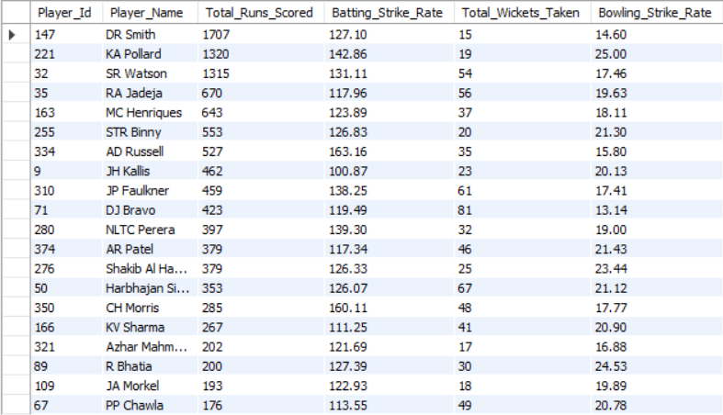

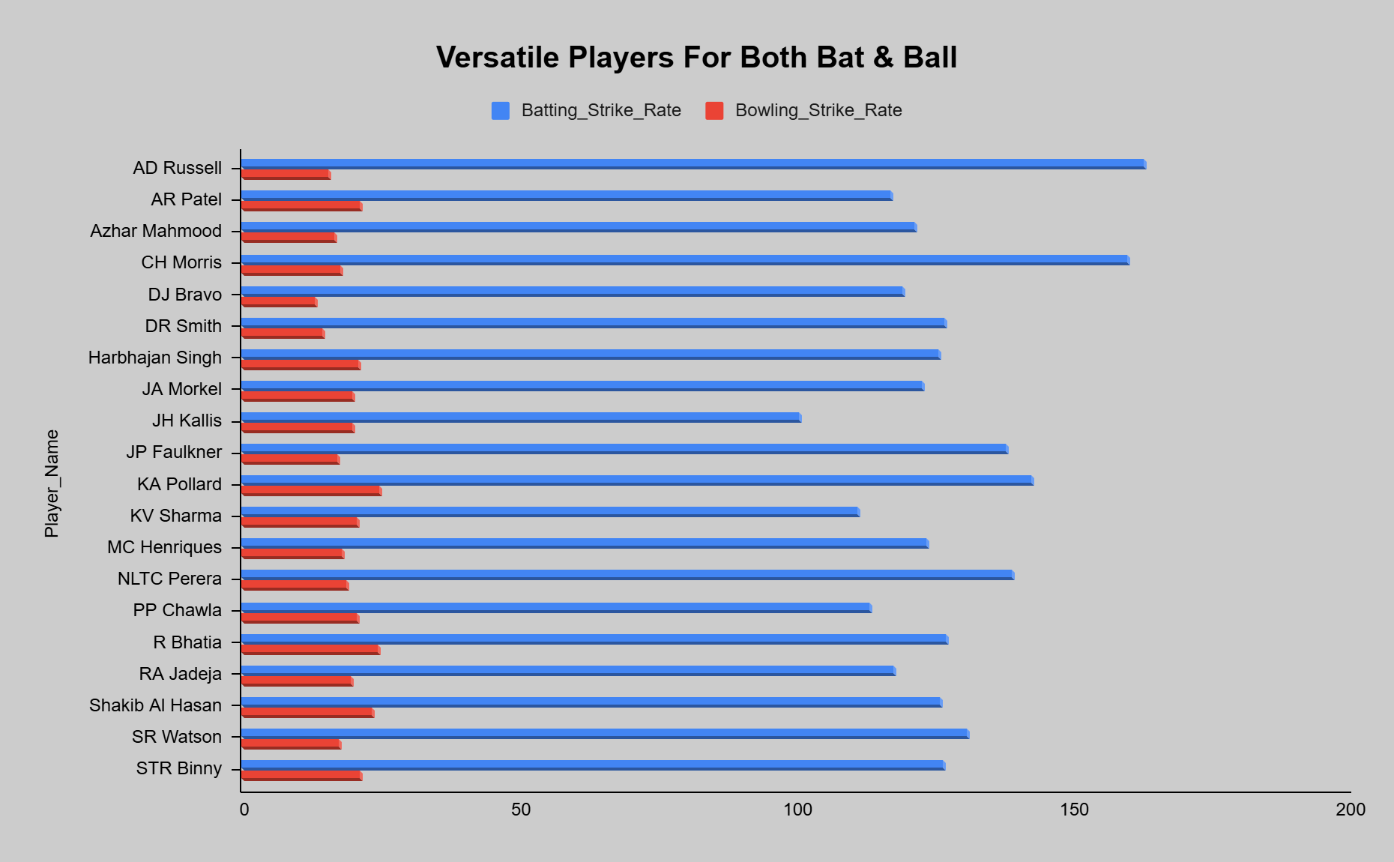
Approach:
This query identifies versatile (all-rounder) players who perform well in both batting and bowling across the last 4 seasons. It combines two datasets — one for batting (total runs, strike rate) and one for bowling (wickets, bowling strike rate) — and filters players meeting both batting and bowling performance thresholds.
Insights:
- Players with Batting Strike Rate ≥ 100, Bowling Strike Rate ≤ 40, and ≥ 15 wickets are the most effective all-rounders.
- These players provide dual value — they score quickly and take key wickets, giving strategic flexibility to the team.
Recommendations:
- Build the team core around the top all-rounders to maintain balance.
- Use them in middle-order positions or as bowling options in critical overs.

5. Are there players whose presence positively influences the morale and performance of the team? (Justify your answer using visualization)
A. In IPL, the total number of overs will be 20 for each team in each match.

These 20 overs can be divided into three parts: power play, middle overs, and death overs.

From the above scenario, some players are most suited for a particular situation and influence the performance of the team.

For example, some batsmen perform so good in power play and hit more runs, or some bowlers perform so good in death overs and take more wickets. Like this, I’ve retrieved some players' data who are good in power play, middle, and death overs for both batsmen and bowlers.

The query below will retrieve the top 20 batsmen's performances in power play, middle overs, and death overs, and the following table and clustered bar chart contain the data of those players.
select
ad.Striker as Player_Id,
p.Player_Name,
count(distinct ad.Match_Id) as Total_Matches_Played,
sum(ad.Runs_Scored) as Total_Runs_Scored,
sum(case when ad.Over_Id between 1 and 6 then ad.Runs_Scored else 0 end) as Power_Play_Total_Runs_Scored,
sum(case when ad.Over_Id between 7 and 15 then ad.Runs_Scored else 0 end) as Middle_Overs_Total_Runs_Scored,
sum(case when ad.Over_Id between 16 and 20 then ad.Runs_Scored else 0 end) as Death_Overs_Total_Runs_Scored
from all_data ad
join player p
on ad.Striker = p.Player_Id
where ad.Season_Id between 6 and 9
group by ad.Striker, p.Player_Name
order by Total_Runs_Scored desc
limit 20;
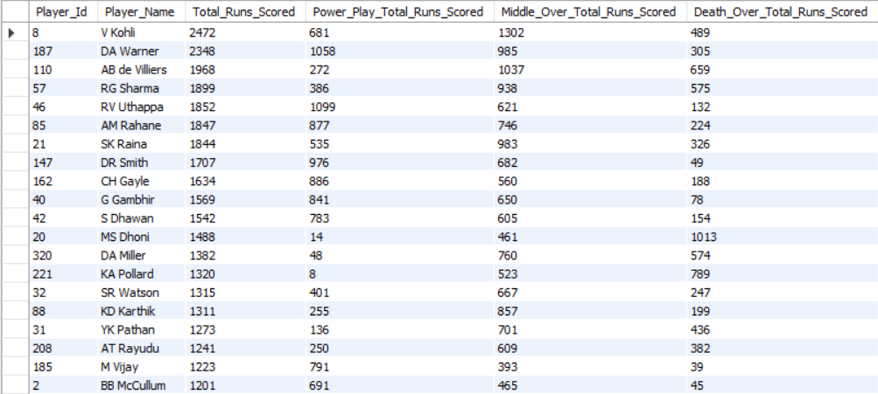

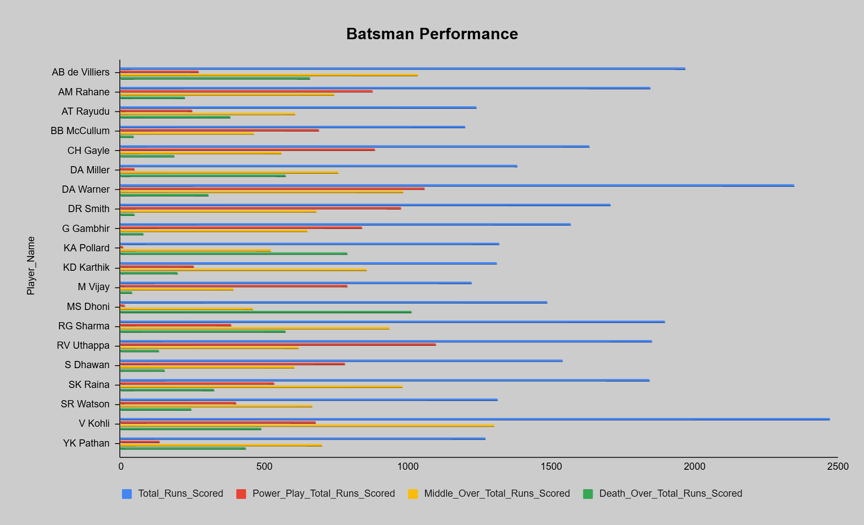

The query below will retrieve the top 20 Bowlers' performances in power play, middle overs, and death overs, and the following table and clustered bar chart contain the data of those players.
select
ad.Bowler as Player_Id,
p.Player_Name,
count(distinct ad.Match_Id) as Total_Matches_Played,
sum(case when ad.Player_Out is not null then 1 else 0 end) as Total_Wickets_Taken,
sum(case when ad.Player_Out is not null and ad.Over_Id between 1 and 6 then 1 else 0 end) as Wickets_Taken_in_Power_Play,
sum(case when ad.Player_Out is not null and ad.Over_Id between 7 and 15 then 1 else 0 end) as Wickets_Taken_in_Middle_Overs,
sum(case when ad.Player_Out is not null and ad.Over_Id between 16 and 20 then 1 else 0 end) as Wickets_Taken_in_Death_Overs
from all_data ad
join player p
on ad.Bowler = p.Player_Id
where ad.Season_Id between 6 and 9
group by ad.Bowler, p.Player_Name
order by Total_Wickets_Taken desc
limit 20;
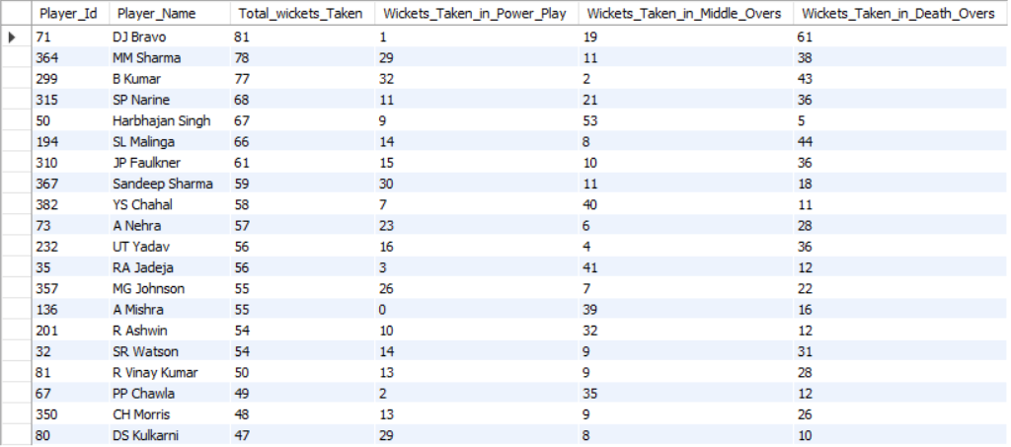
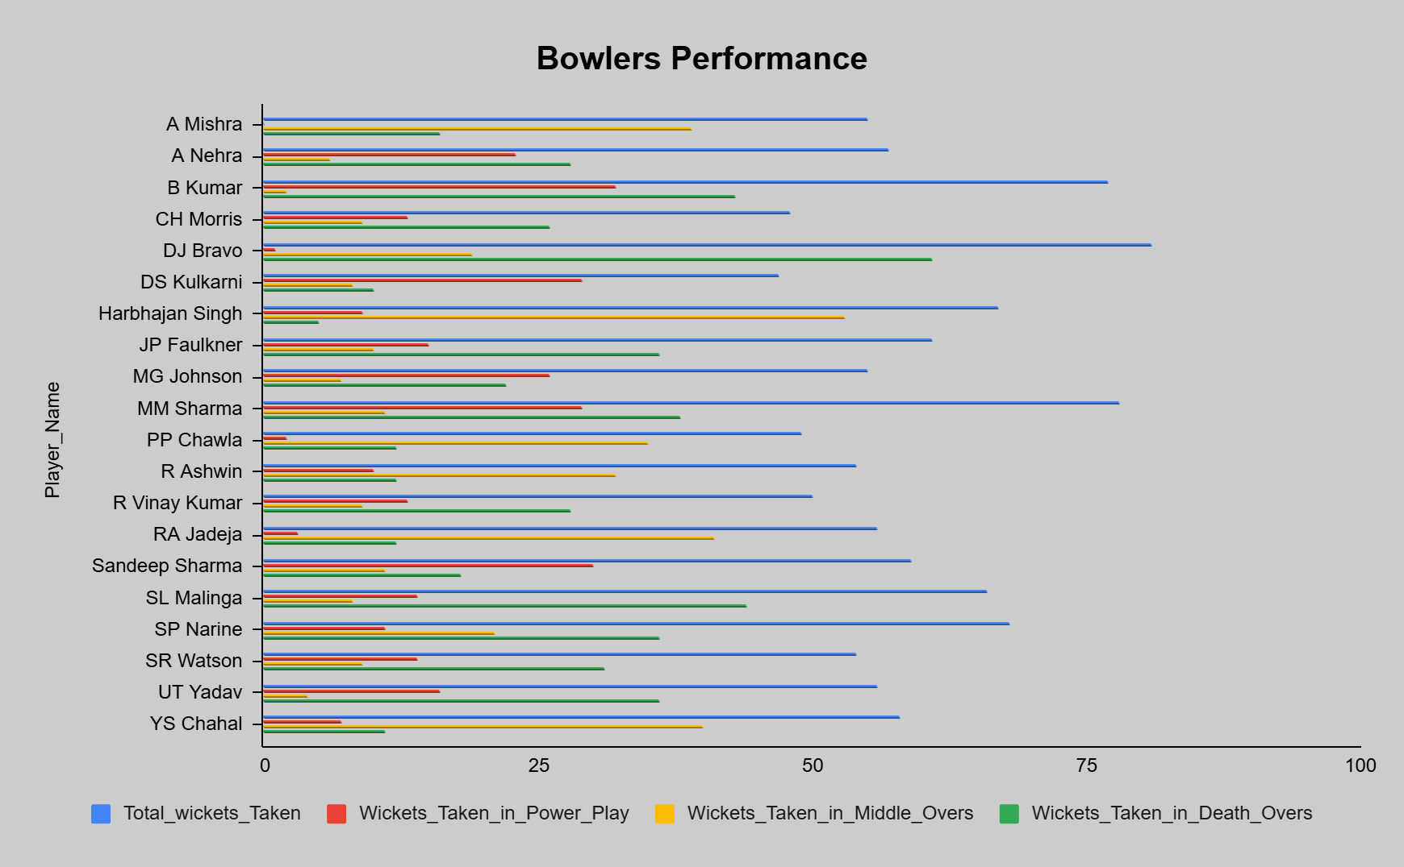
Approach:
The query analyzes batsmen’s performances across different match phases — Power Play (overs 1–6), Middle Overs (7–15), and Death Overs (16–20). By breaking down runs scored by over type, we can identify players who perform best in specific situations and contribute significantly to team morale and momentum.
Insights:
- Some players dominate in Power Play, giving the team an early advantage.
- Others excel in Middle Overs, maintaining steady scoring.
- A few specialize in Death Overs, finishing strong with quick runs.
- These situational performers lift team confidence and influence outcomes positively through their consistency under pressure.
Recommendations:
- Use Power Play specialists (aggressive openers) at the top order.
- Rely on Middle Overs anchors to stabilize the innings.
- Deploy Death Over finishers strategically for maximum impact.

6. What would you suggest to RCB before going to the mega auction?
A. I’ve derived the RCB’s past 4 seasons' total wins and losses of different types, like wins or losses by runs or tie or wickets in each season, to understand the overall winning percentage of the team in each season and in which aspect the team’s performance is weak.
The query below will retrieve the overall data, and the following table and column chart will represent the data visually.
select
m.Win_Type as Win_Id,
wb.Win_Type,
count(m.Match_Id) as Total_Matches_Played,
sum(case when m.Match_Winner = 2 then 1 else 0 end) as Matches_Won,
sum(case when m.Match_Winner != 2 then 1 else 0 end) as Matches_Lost
from matches m
join win_by wb
on m.Win_Type = wb.Win_Id
where
(m.Team_1 = 2 or m.Team_2 = 2) and
(m.Season_Id between 6 and 9) and
m.Outcome_Type != 2
group by m.Win_Type, wb.Win_Type;
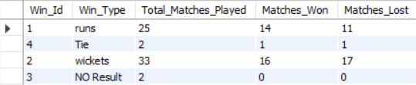
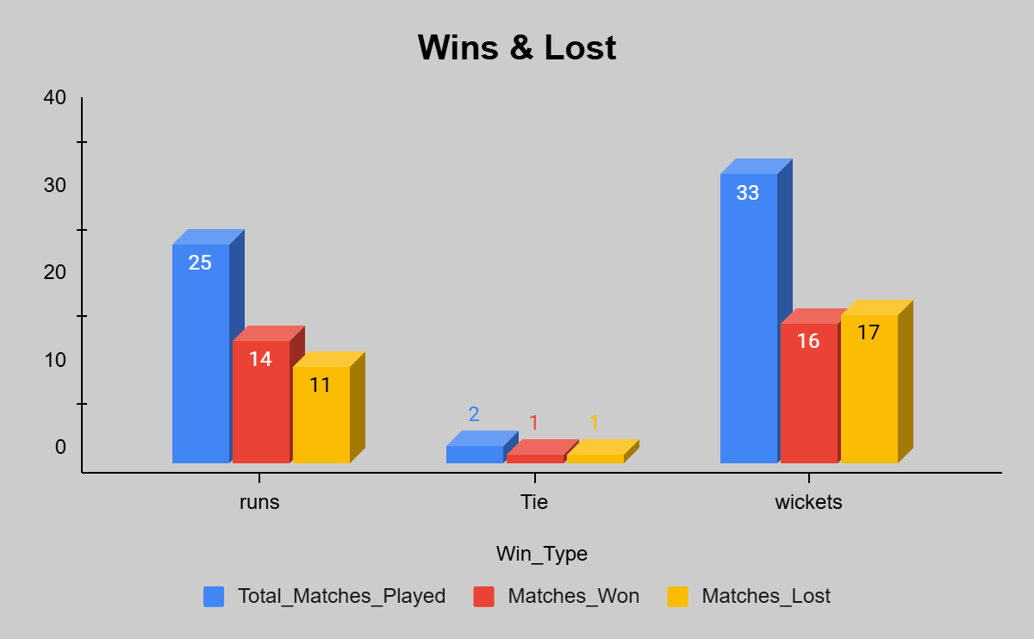
From the above table and chart, it is clearly understandable that the team's performance is somewhat weak in chasing the target.

So, in this case, my suggestion to the RCB is to focus on batsmen who are good at pulling more runs, especially in power play and death overs.

And one more thing I’ve noticed is team requires all-rounders. All-rounders are very important for any team to pull more runs and take more wickets in crucial times.
Because having the best batsmen and bowlers separately may not help the team in every situation, all-rounders are very necessary.

The top 20 all-rounders in the given dataset who are good in both bat and bowl are given below.
With batting_data as
(select
ad.Striker as Player_Id,
p.Player_Name,
sum(ad.Runs_Scored) as Total_Runs_Scored,
round((sum(ad.Runs_Scored)/count(ad.Ball_Id))*100, 2) as Batting_Strike_Rate
from all_data ad
join player p
on ad.Striker = p.Player_Id
where ad.Season_Id between 6 and 9
group by ad.Striker, p.Player_Name),

bowling_data as
(select
ad.Bowler as Player_Id,
p.Player_Name,
sum(case when ad.Player_Out is not null then 1 else 0 end) as Total_Wickets_Taken,
round(count(ad.Ball_Id)/sum(case when ad.Player_Out is not null then 1 else 0 end), 2) as Bowling_Strike_Rate
from all_data ad
join player p
on ad.Bowler = p.Player_Id
where ad.Season_Id between 6 and 9
group by ad.Bowler, p.Player_Name)

select
t1.Player_Id,
t1.Player_Name,
t1.Total_Runs_Scored,
t1.Batting_Strike_Rate,
t2.Total_Wickets_Taken,
t2.Bowling_Strike_Rate
from batting_data t1
join bowling_data t2
on t1.Player_Id = t2.Player_Id
where
t1.Batting_Strike_Rate >= 100 and
t2.Bowling_Strike_Rate <= 40 and
t2.Total_Wickets_Taken >= 15
order by t1.Total_Runs_Scored desc, t2.Total_Wickets_Taken desc
limit 20;
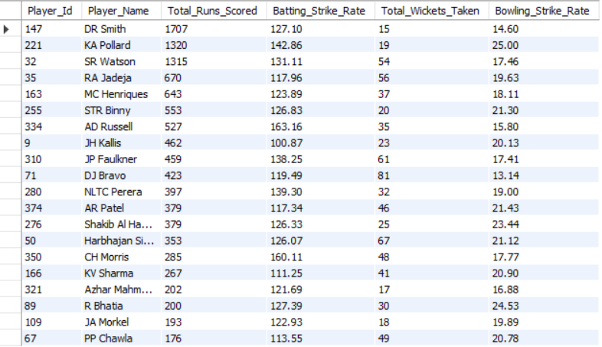


Approach:
The analysis evaluates RCB’s performance trends over the past 4 seasons, focusing on how they won or lost matches by runs, wickets, or ties. The goal is to identify patterns and weaknesses to help form a better auction strategy.
Insights:
- RCB’s winning percentage is inconsistent across seasons.
- The team shows weakness while chasing targets, suggesting pressure-handling issues in the second innings.
- The lack of strong all-rounders reduces flexibility in both batting depth and bowling options.
- Players with high strike rates in Power Play and Death Overs can significantly improve match outcomes.
Recommendations:
- Prioritize batsmen who perform well under pressure, especially strong chasers and finishers.
- Invest in all-rounders who can contribute in both departments — boosting stability and adaptability.
- Strengthen bowling depth with wicket-taking bowlers for early breakthroughs.

7. What do you think could be the factors contributing to the high-scoring matches and the impact on viewership and team strategies
A. There are a few factors that will show a huge impact on viewership and team strategies.

Among them, I feel the important ones are below:
a. Venues show higher impact on viewership and team strategies, which means shorter boundaries mean more runs. So each venue has its own kind of favourable things for both batting and bowling teams.

The venues that have average runs per match of more than 300 are retrieved by below query, and the following table will represent the data.
select
ad.Venue_Id,
v.Venue_Name,
count(distinct ad.Match_Id) as Total_Matches_Held,
sum(ad.Runs_Scored) as Total_Runs_Scored,
round(sum(ad.Runs_Scored)/count(distinct ad.Match_Id), 2) as Average_Runs_Per_Match
from all_data ad
join venue v
on ad.Venue_Id = v.Venue_Id
where ad.Season_Id between 6 and 9
group by ad.Venue_Id, v.Venue_Name
having Average_Runs_Per_Match > 300
order by Total_Runs_Scored desc, Average_Runs_Per_Match desc;
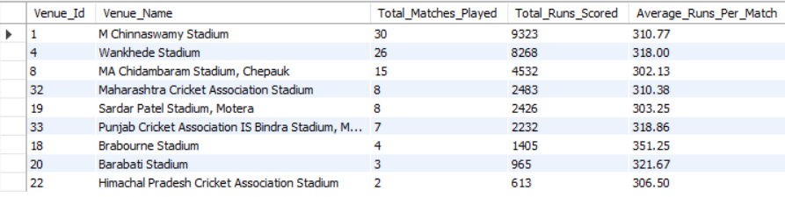
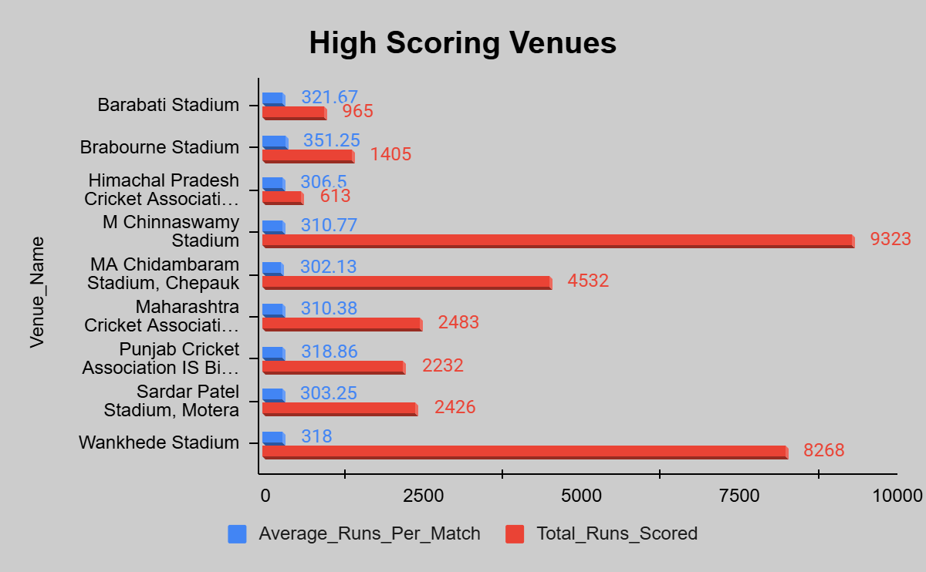

b. Each team's power play and death over batting performances, as players play aggressively in these overs to score more runs in both cases, while chasing or setting targets.

The team’s power play and death overs performances are retrieved from the query below, and the following chart will display the team’s performance data.
select
t.Team_Id,
t.Team_name,
sum(ad.Runs_Scored) as Total_Runs_Scored,
sum(case when ad.Over_Id between 1 and 6 then ad.Runs_Scored else 0 end) as Total_Power_Play_Runs,
sum(case when ad.Over_Id between 16 and 20 then ad.Runs_Scored else 0 end) as Total_Death_Over_Runs
from team t
join matches m
on t.Team_Id = m.Team_1 or t.Team_Id = m.Team_2
join all_data ad
on m.Match_Id = ad.Match_Id and t.Team_Id = ad.Team_batting
where ad.Season_Id between 6 and 9
group by t.Team_Id, t.Team_Name
order by t.Team_Id;
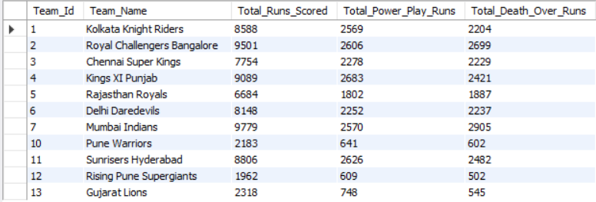
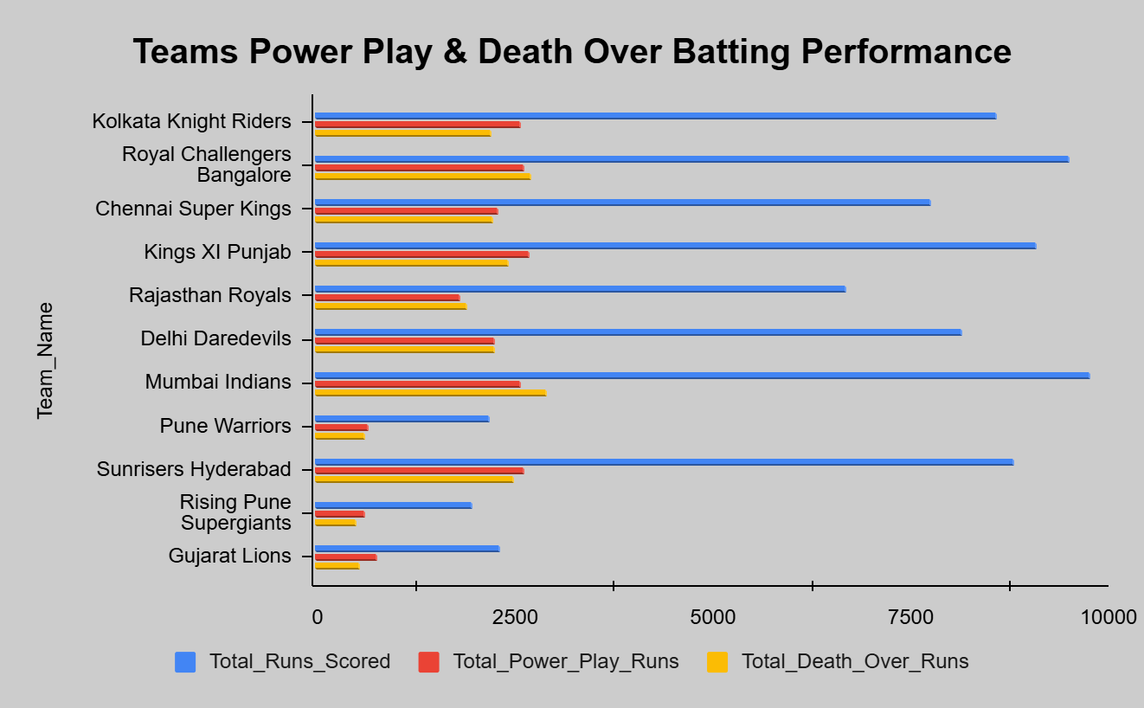
Approach:
Analyzed venues and batting performances in different overs to identify factors behind high-scoring matches.
Insights:
- Venues with shorter boundaries and flat pitches (like Wankhede, Chinnaswamy) lead to higher average scores and more exciting matches.
- Teams scoring heavily in Power Play and Death Overs contribute to most highest totals.
Recommendations:
- Build venue-specific strategies — use power hitters on batting-friendly pitches.
- Focus on aggressive batsmen and death-over specialists.
8. Analyze the impact of home-ground advantage on team performance and identify strategies to maximize this advantage for RCB.
A. The impact of home-ground advantage on team performance for RCB is retrieved from the following query for the past 4 seasons.
select
case when m.Venue_Id = 1 then "Home" else "Away" end as Venue_Type,
count(distinct m.Match_Id) as Total_Matches_Played,
sum(case when m.Match_Winner = 2 then 1 else 0 end) as Winning_Count,
sum(case when m.Match_Winner != 2 then 1 else 0 end) as Losing_Count,
round((sum(case when m.Match_Winner = 2 then 1 else 0 end)/count(distinct m.Match_Id))*100, 2) as Winning_Percentage
from matches m
join venue v
on m.Venue_Id = v.Venue_Id
where (m.Team_1 = 2 or m.Team_2 = 2) and m.Outcome_Type != 2
group by Venue_Type
order by Winning_Percentage desc;
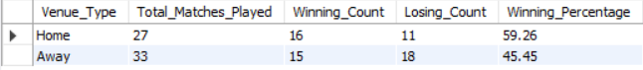

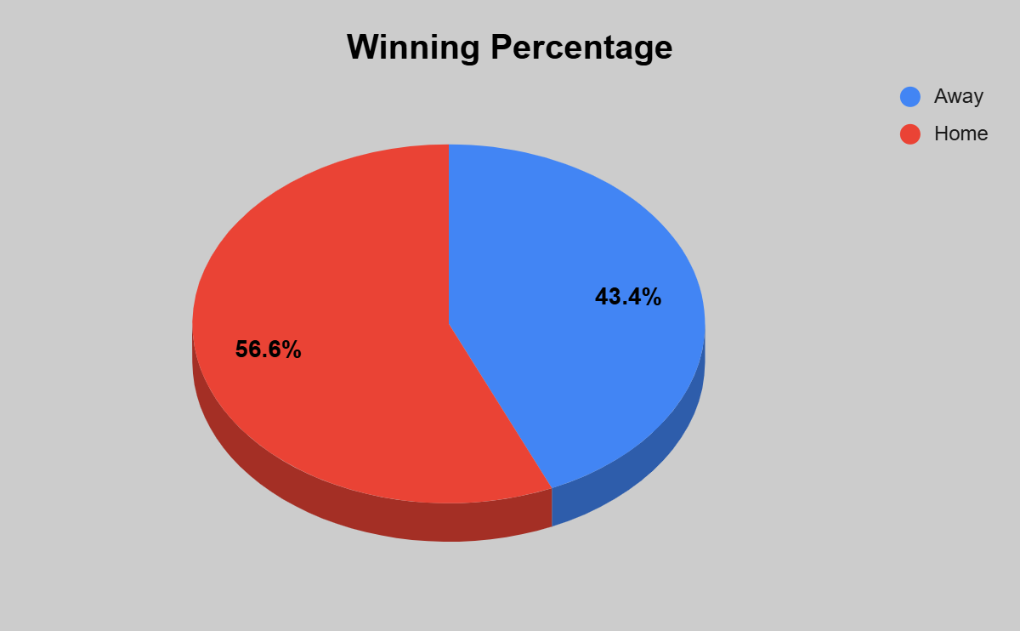

From the above pie chart, we can observe that the winning percentage is higher at home ground for RCB.

The strategies to maximize the home-ground advantage for RCB are below:
- Chinnaswamy Stadium in Bengaluru is the home ground for RCB, and it is the smallest compared to other venues.
- This will be an advantage for RCB as well as other teams, because smaller boundaries lead to more runs.
- If RCB has to bat first, then the players who have a higher strike rate should be played in power play and death overs. All-rounders should take care of the middle overs to pull more runs.
- Or if RCB has the field first, then the bowlers should stop the opponents from scoring more runs.
- The bowlers who have a good bowling strike rate should bowl the power play and death overs to take more wickets in a crucial time.
Approach:
Analyzed RCB’s match outcomes at home (Chinnaswamy Stadium) vs away venues to measure the effect of home-ground advantage.
Insights:
- RCB’s winning percentage is higher at home, showing a clear home-ground advantage.
- The small boundaries at Chinnaswamy make it a high-scoring venue, benefiting strong hitters but also challenging bowlers.
Recommendations:
- Batting strategy: Use power hitters in Power Play and Death Overs to maximize runs.
- Bowling strategy: Deploy strike bowlers early and in death overs to control scoring.
- Team composition: Focus on all-rounders to balance batting and bowling in high-scoring conditions.

9. Come up with a visual and analytical analysis of the RCB's past season's performance and potential reasons for them not winning a trophy.
A. RCB’s past 4 seasons' winning performance is retrieved by using the below query, and the following pie chart will represent the data visually.
select
m.Season_Id,
s.Season_Year,
count(case when m.Team_1 = 2 or m.Team_2 = 2 then m.Match_Id end) as Total_Matches_Played,
sum(case when (m.Team_1 = 2 or m.Team_2 = 2) and m.Match_Winner = 2 then 1 else 0 end) as Total_Matches_Won,
round((sum(case when (m.Team_1 = 2 or m.Team_2 = 2) and m.Match_Winner = 2 then 1 else 0 end)/count(case when m.Team_1 = 2 or m.Team_2 = 2 then m.Match_Id end))*100, 2) as Win_Percentage
from matches m
join season s
on m.Season_Id = s.Season_Id
where m.Season_Id between 6 and 9
group by m.Season_Id;
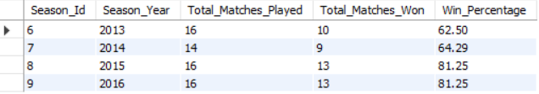
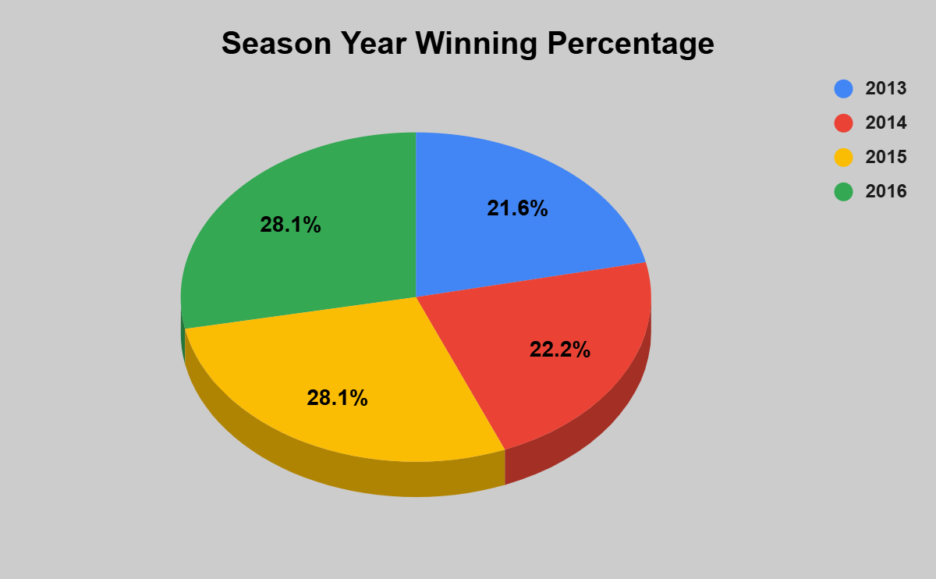

From the above chart, it is clearly understandable that in the past 4 seasons, RCB has not crossed 60% of the winning percentage of total matches they played in each season.

Based on the above scenario, I’ve derived two potential reasons for RCB has a lower winning percentage.

1. Depending more on a few batsmen to score more runs even in the middle overs.

The query below will retrieve the players' details on whom the whole team is depending on to score more.
select
ad.Striker as Player_Id,
p.Player_Name,
round(sum(ad.Runs_Scored)/count(distinct concat(ad.Match_Id, "_", ad.Innings_No)), 2) as Avg_Runs_Scored_Per_Match
from all_data ad
join player p
on ad.Striker = p.Player_Id
where
(ad.Season_Id between 6 and 9) and
ad.Team_Batting = 2
group by ad.Striker, p.Player_Name
having Avg_Runs_Scored_Per_Match > 30
order by Avg_Runs_Scored_Per_Match desc;
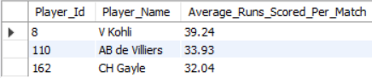
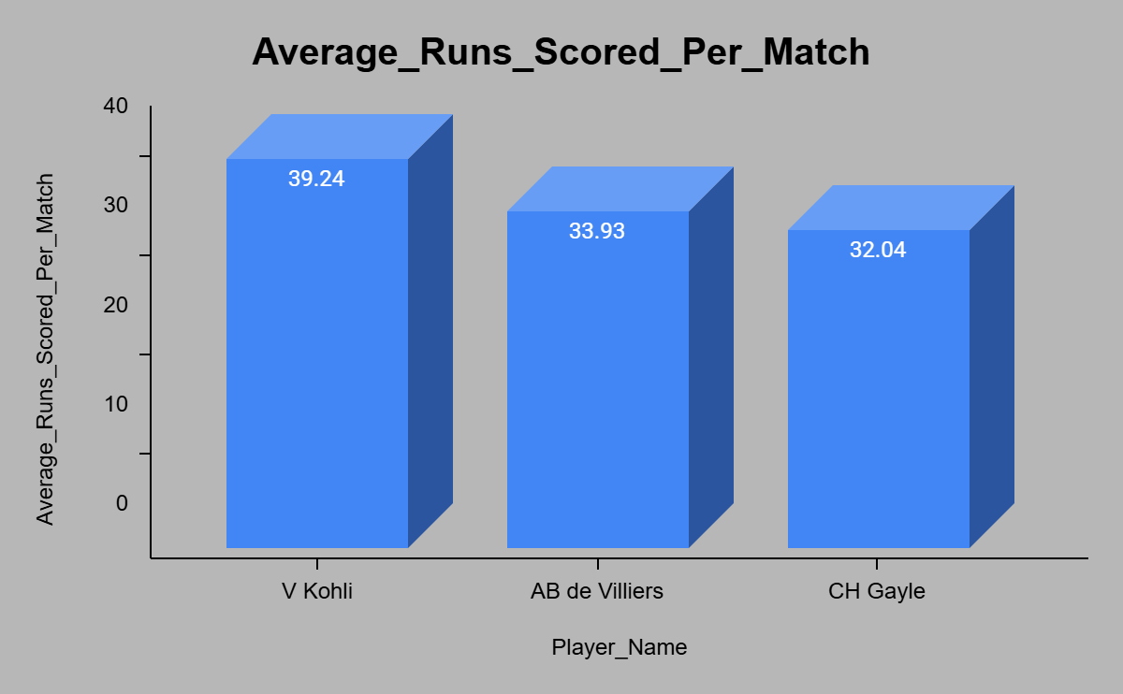
From the past 4 seasons, there are only 3 players who have an average runs scored per match greater than 30.

Completely depending on these players in power play, middle, and death overs to score more runs is not possible in every match.

So the team needs efficient players who can effectively cover middle overs for score pulling, and top batsmen having a higher average runs will cover power play and death overs to pull more runs while chasing or setting targets.

2. Depending more on a few bowlers to take more wickets or to control opponents' score, even in the middle overs.

The query below will retrieve the players' details on whom the whole team is depending on to score more.
select
ad.Bowler as Player_Id,
p.Player_Name,
round(sum(case when ad.Player_Out is not null then 1 else 0 end)/count(distinct ad.Match_Id), 2) as Avg_Wickets_Taken_Per_Match
from all_data ad
join player p
on ad.Bowler = p.Player_Id
where
(ad.Season_Id between 6 and 9) and
ad.Team_Bowling = 2
group by ad.Bowler, p.Player_Name
having Avg_Wickets_Taken_Per_Match > 1.5
order by Avg_Wickets_Taken_Per_Match desc;
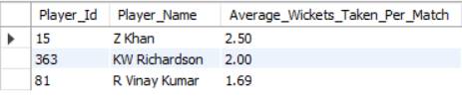

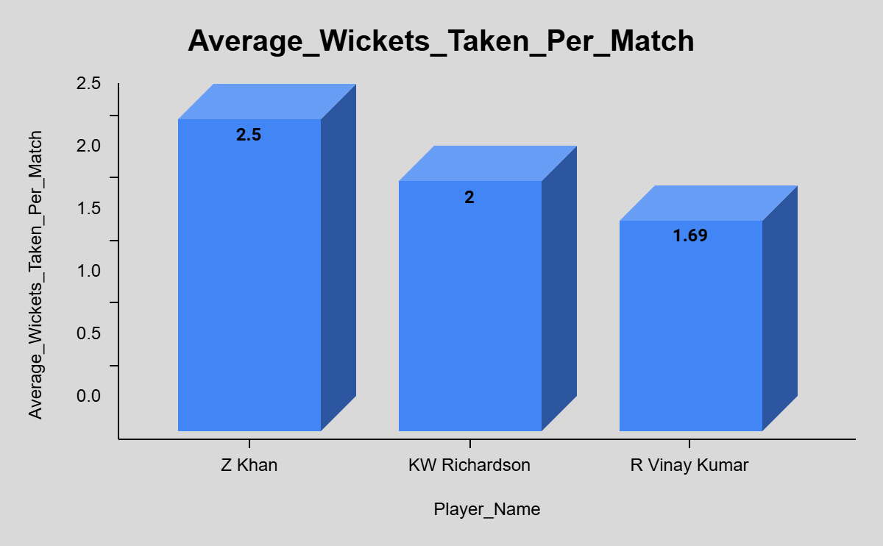
From the past 4 seasons, there are only 3 players who have an average of wickets taken per match greater than 1.5, which means at least one wicket taken in one match.

Completely depending on these players in power play, middle, and death overs to take more wickets or to stop opponents' score is not possible in every match.

So the team needs efficient players who can effectively cover middle overs for stopping opponents' score and take wickets, and top bowlers who have a higher average wickets taken will cover power play and death overs to take wickets.
Approach
- Retrieved RCB’s win percentage across the last 4 IPL seasons using match data.
- Analyzed batting and bowling dependencies by calculating average runs scored and wickets taken per match.
- Used visualizations (pie/bar charts) to compare team and player performances across seasons.
Insights
- Win rate below 60% in all 4 seasons → shows inconsistency in overall team performance.
- High dependency on 3 key batsmen for scoring; lack of contribution from middle-order players.
- Only a few bowlers consistently take wickets (>1.5 per match), indicating weak bowling depth.
- Performance drops significantly in the middle overs, both while batting and bowling.
Recommendations
- Strengthen Middle Order: Train or recruit batsmen who can rotate strike and accelerate in middle overs.
- Diversify Bowling Attack: Add bowlers skilled in different phases (powerplay, middle, death overs).
- Balance Team Composition: Reduce reliance on top players; promote role clarity across all players.
- Data-Driven Strategies: Use past performance analytics to decide match roles and bowling orders.
- Fitness & Consistency Focus: Ensure key players maintain performance throughout the season.

10. How would you approach this problem if the objective and subjective questions weren't given?
A. If the objective and subjective questions weren't provided, my approach to analyzing the IPL dataset, particularly for a team like RCB, would be as follows:
1. Understand the Dataset:
- First, review the IPL dataset thoroughly to understand its structure, the available tables, and key columns such as players, matches, teams, venues, and performances.
- Identify important metrics related to team performance, such as wins, losses, individual player stats (batting, bowling, and fielding), and venue-related statistics.
2. Define the Analytical Goals:
- Without predefined questions, I would focus on generating insights across several dimensions:
- Team Performance Trends: Analyze overall team performance across seasons—win/loss ratios, home/away performance, and tournament progression.
- Player Contributions: Break down individual player contributions to identify key performers, top run-scorers, and wicket-takers, as well as those with all-round abilities.
- Player Performance Under Pressure: Analyze how players perform under critical conditions like knockout matches, death overs, and high-pressure situations.
- Team Strengths and Weaknesses: Identify the team's consistent strengths (e.g., batting power) and weaknesses (e.g., bowling, fielding, middle-order stability).
- Match Results and Patterns: Look for recurring patterns in match results, such as winning the toss, batting first, or playing at certain venues.
3. Perform Statistical Analysis:
- Match Analysis: Investigate match-level statistics to identify key factors contributing to wins and losses (e.g., toss decisions, chasing records, target scores).
- Player-Level Analysis: Explore batting averages, strike rates, bowling economies, and all-rounder effectiveness. Highlight players who contribute consistently in both departments (batting and bowling).
- Venue Advantage: Investigate home-ground advantage and how RCB fares at home compared to away matches.
4. Visualize Insights, I’ll use data visualization tools (like Excel, Power BI, or Tableau) to create charts and graphs:
- Win/loss trends across seasons.
- Player performances (e.g., top scorers, best bowlers).
- Home vs away performance comparisons.
- Toss impact on match outcomes.
5. Generate Recommendations based on the analysis and provide actionable recommendations:
- Squad composition and potential areas for improvement.
- Strategies for winning in high-stakes matches.
- Player retention and acquisition for a balanced team.

This method would create a comprehensive analysis without relying on predefined questions, enabling insights into RCB’s overall performance and potential improvements.

11. In the "Match" table, some entries in the "Opponent_Team" column are incorrectly spelled as "Delhi_Capitals" instead of "Delhi_Daredevils". Write an SQL query to replace all occurrences of "Delhi_Capitals" with "Delhi_Daredevils".
A. In the given IPL Dataset, there is no such column name, i.e, "Opponent_Team" in the “Match” table, so there will be no scope to replace the name in the match column.

I’ve also checked the “Team” table by using the below query, but it is named “Delhi_Daredevils”:
Select * from Team;

If in case it is “Delhi_Capitals”, we get the team name here, we can change the team name from "Delhi_Capitals" to "Delhi_Daredevils" by using the below query.
select Team_Id, replace(Team_name,"Delhi Daredevils","Delhi Capitals") as Team_name from team;

